VISVESVARAYA TECHNOLOGICAL UNIVERSITY
“JnanaSangama”, Belgaum -590014, Karnataka.

LAB REPORT
on
Artificial Intelligence (23CS5PCAIN)
Submitted by
Sameksha (1BM23CS292)
in partial fulfillment for the award of the degree of
BACHELOR OF ENGINEERING
in
COMPUTER SCIENCE AND ENGINEERING

B.M.S. COLLEGE OF ENGINEERING
(Autonomous Institution under VTU)
BENGALURU-560019
Aug 2025 to Dec 2025

B.M.S. College of Engineering,
Bull Temple Road, Bangalore 560019
(Affiliated To Visvesvaraya Technological University, Belgaum)
Department of Computer Science and Engineering

CERTIFICATE
This is to certify that the Lab work entitled “Artificial Intelligence (23CS5PCAIN)” carried out by Sameksha (1BM23CS292), who is bonafide student of B.M.S. College of Engineering. It is in partial fulfillment for the award of Bachelor of Engineering in Computer Science and Engineering of the Visvesvaraya Technological University, Belgaum. The Lab report has been approved as it satisfies the academic requirements in respect of an Artificial Intelligence (23CS5PCAIN) work prescribed for the said degree.

Mrs.Seema Patil  Assistant Professor  Department of CSE, BMSCE | Dr. Kavitha Sooda  Professor & HOD  Department of CSE, BMSCE

Index
Sl.  No. | Date | Experiment Title | Page No.
1 | 30-9-2024 | Implement Tic –Tac –Toe Game  Implement vacuum cleaner agent | 5
2 | 7-10-2024 | Implement 8 puzzle problems using Depth First Search (DFS)  Implement Iterative deepening search algorithm | 15
3 | 14-10-2024 | Implement A* search algorithm | 26
4 | 21-10-2024 | Implement Hill Climbing search algorithm to solve N-Queens problem | 32
5 | 28-10-2024 | Simulated Annealing to Solve 8-Queens problem | 38
6 | 11-11-2024 | Create a knowledge base using propositional logic and show that the given query entails the knowledge base or not. | 40
7 | 2-12-2024 | Implement unification in first order logic | 44
8 | 2-12-2024 | Create a knowledge base consisting of first order logic statements and prove the given query using forward reasoning. | 48
9 | 16-12-2024 | Create a knowledge base consisting of first order logic statements and prove the given query using Resolution | 55
10 | 16-12-2024 | Implement Alpha-Beta Pruning. | 61

Github Link:
https://github.com/sameksha-1bm23cs292/artificial_intelligence

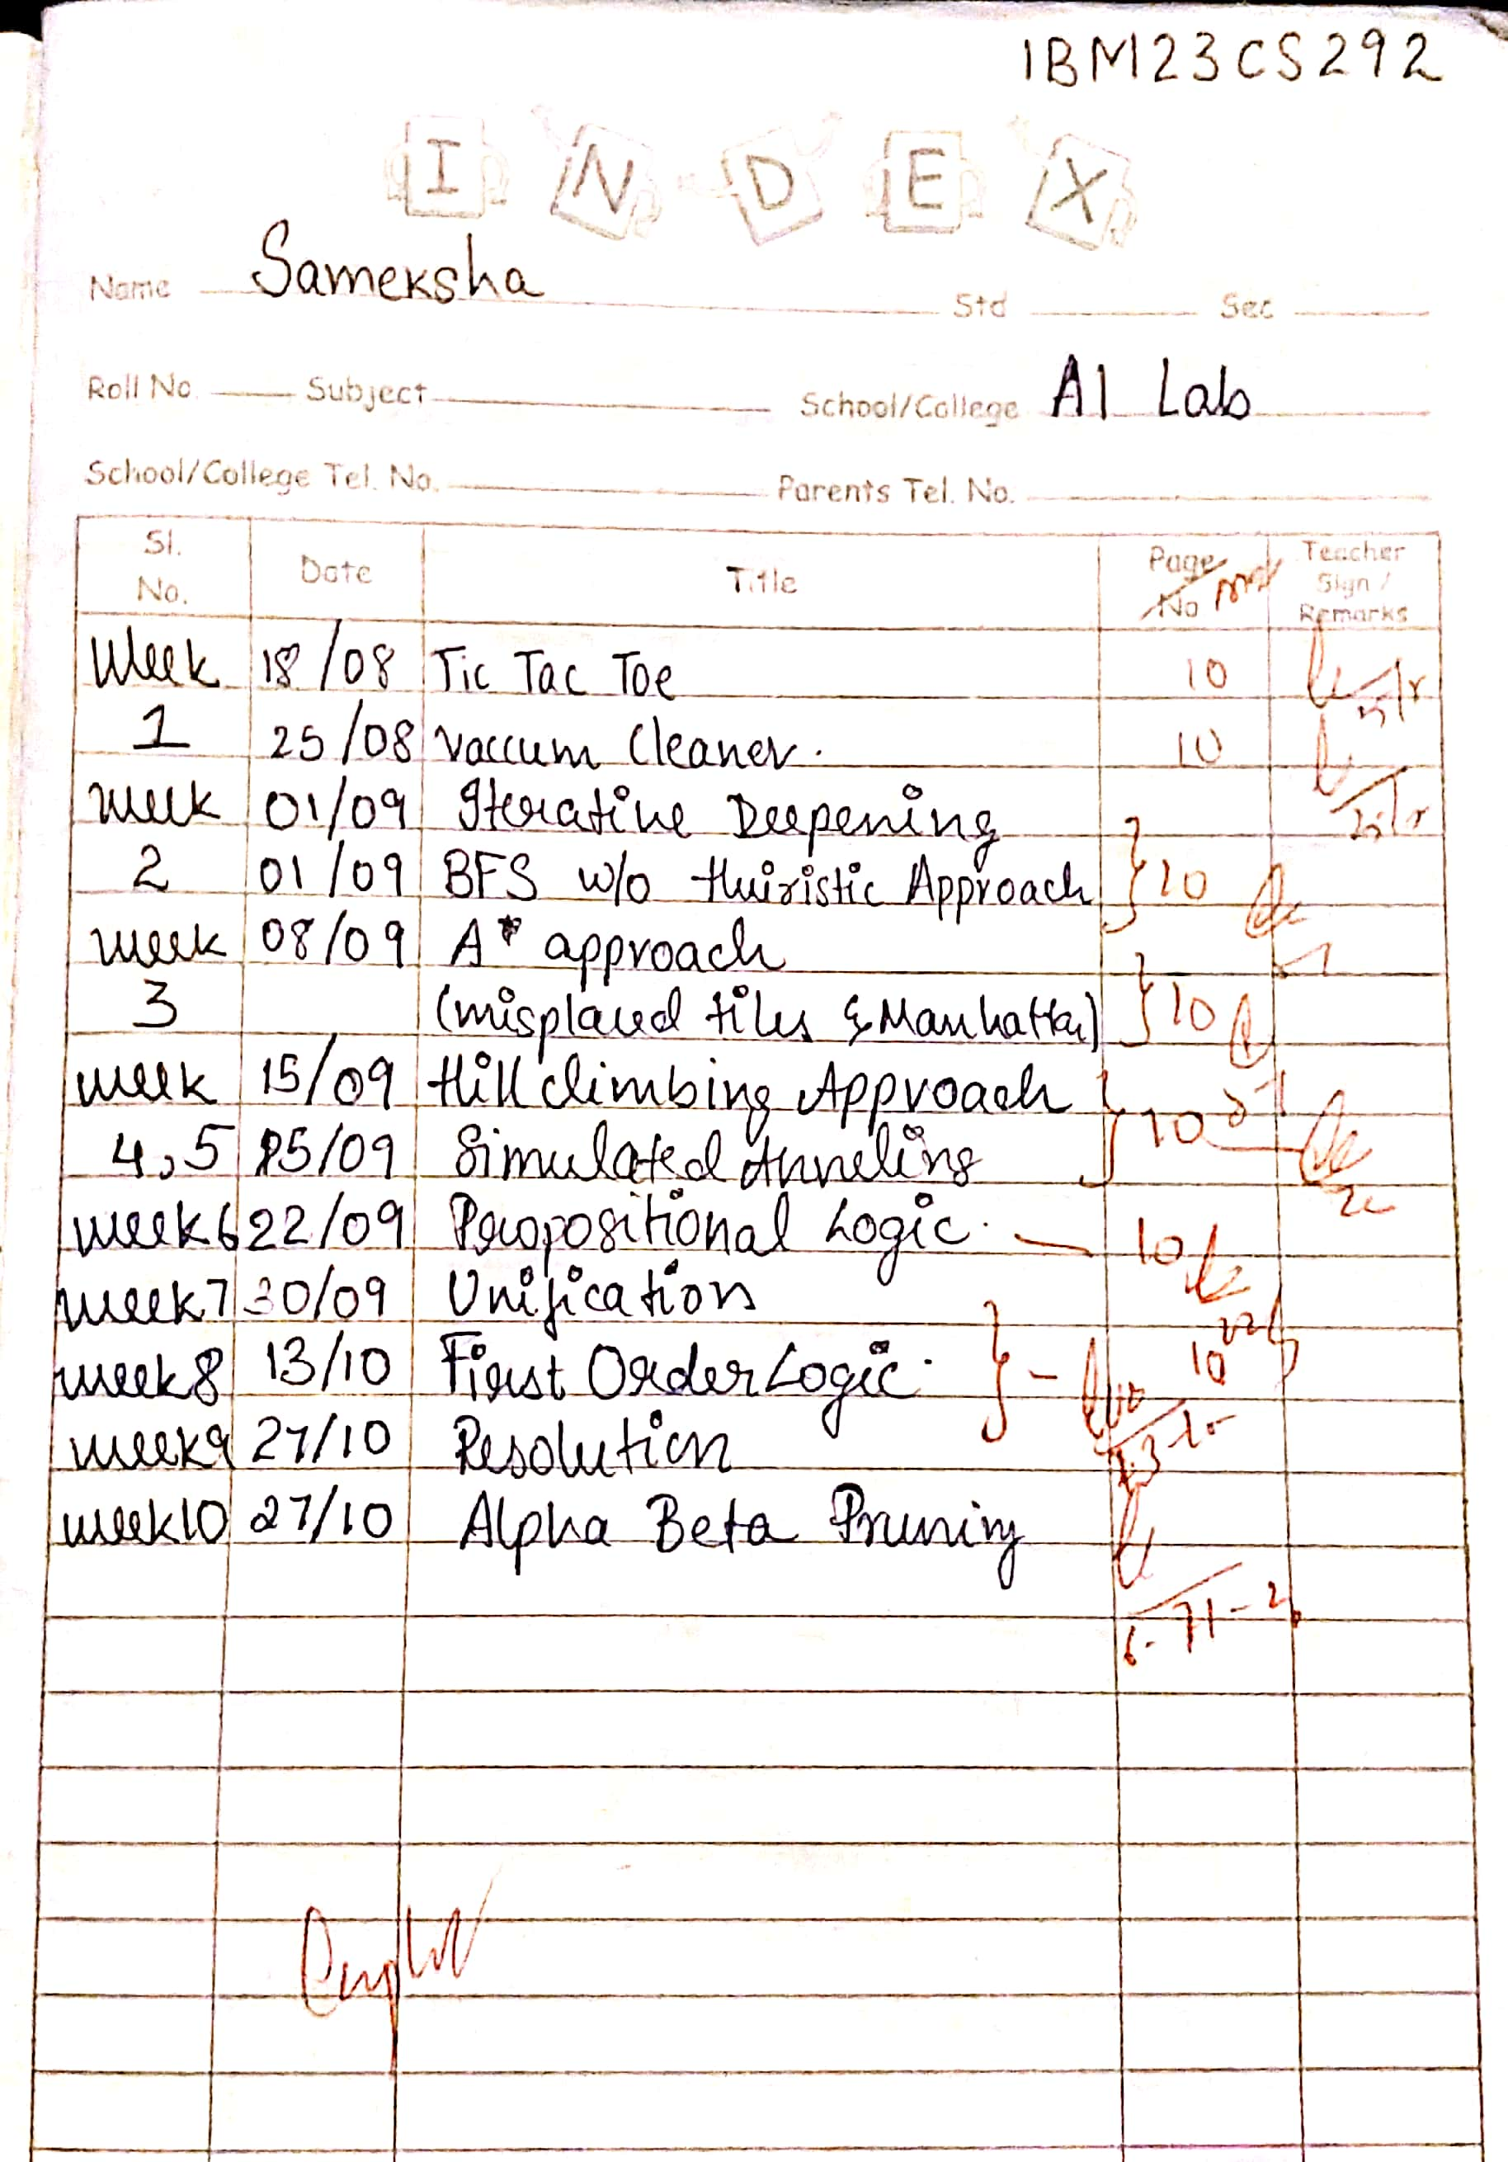

Program 1
Implement Tic –Tac –Toe Game

Algorithm:
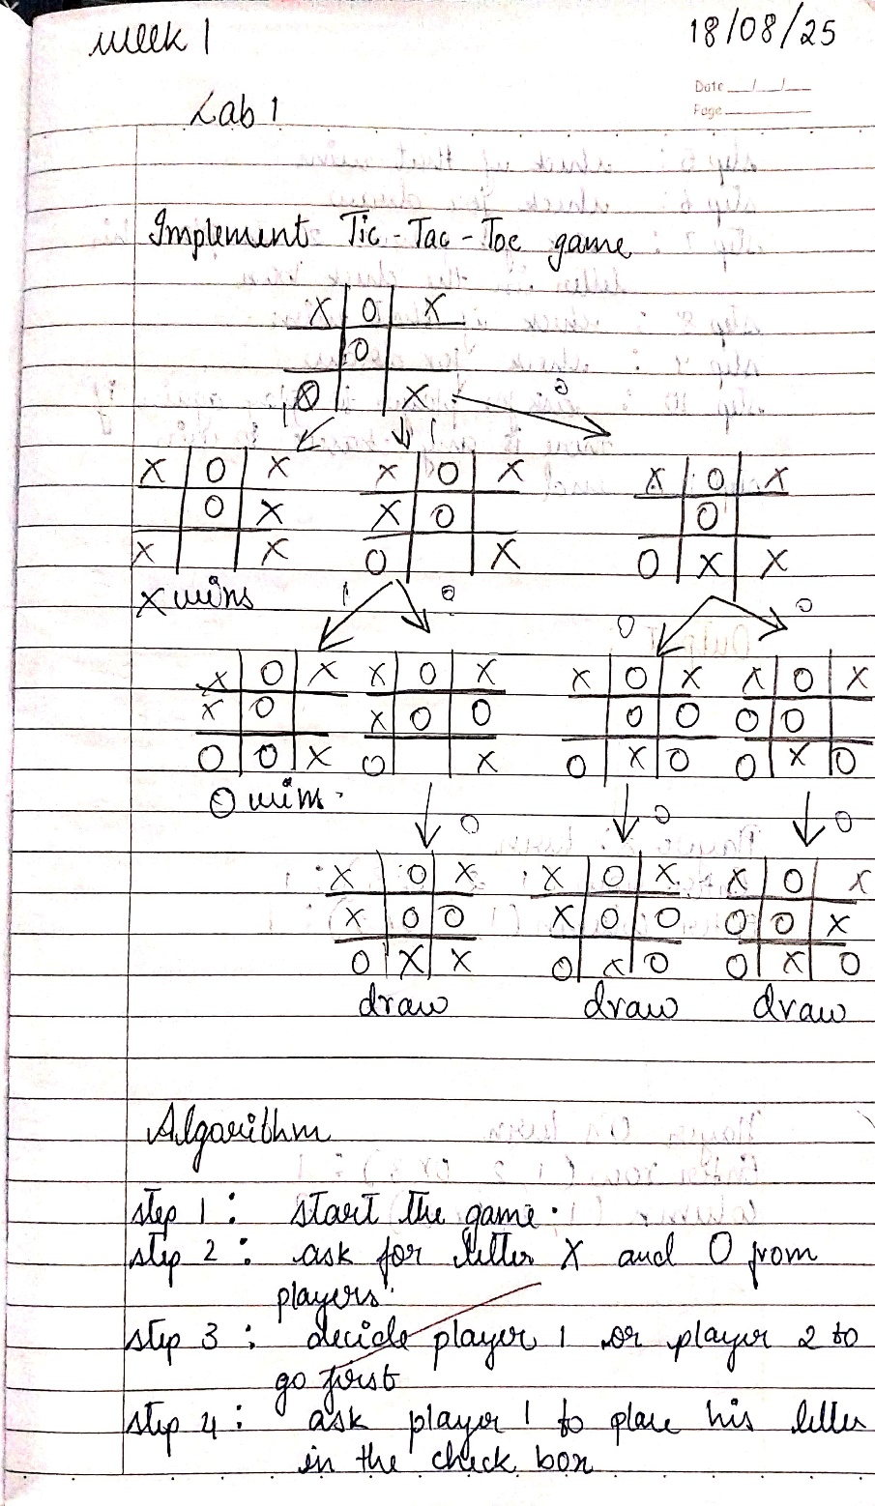

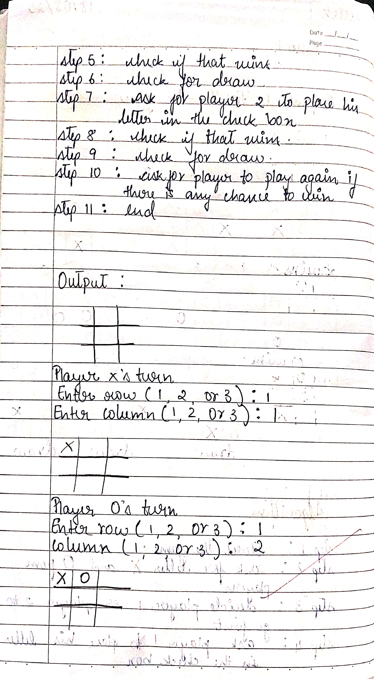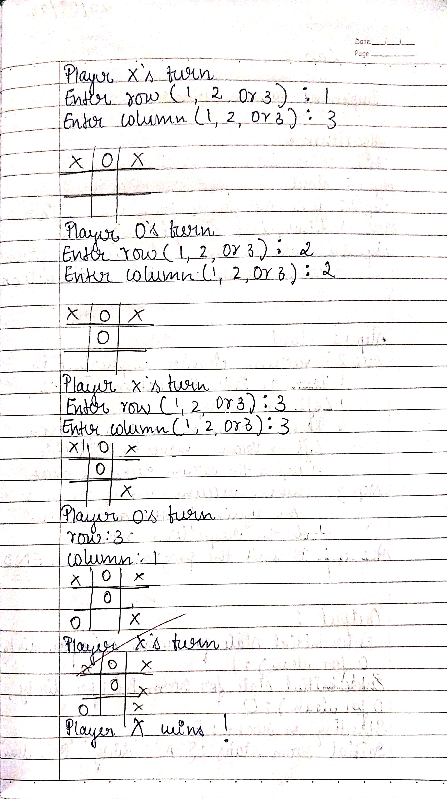
Code:
#week 1 TIC TAC TOE
board = [["-","-","-"],["-","-","-"],["-","-","-"]]
Xrow = {"0":0,"1":0,"2":0}
Orow = {"0":0,"1":0,"2":0}
Xcol = {"0":0,"1":0,"2":0}
Ocol = {"0":0,"1":0,"2":0}
win = False

def checkWin():
global win
for key in Xrow:
if Xrow[key] == 3:
win = True
for key in Xcol:
if Xcol[key] == 3:
win = True
for key in Orow:
if Orow[key] == 3:
win = True
for key in Ocol:
if Ocol[key] == 3:
win = True
if board[0][0] == board[1][1] == board[2][2] != "-":
win = True
if board[0][2] == board[1][1] == board[2][0] != "-":
win = True

def place(symbol, row, col):
if board[row][col] != "-":
print("Can't place at this spot, try again")
return False

if symbol == "1":
board[row][col] = "X"
Xrow[str(row)] += 1
Xcol[str(col)] += 1
elif symbol == "2":
board[row][col] = "O"
Orow[str(row)] += 1
Ocol[str(col)] += 1

return True

def displayBoard():
for row in board:
print(row)
print("\n")

# Game loop
displayBoard()
switch = input("Enter 1 for X, 2 for O to start: ")

while any("-" in row for row in board) and not win:
try:
row = int(input("Enter Row (1-3): "))
col = int(input("Enter Column (1-3): "))
except ValueError:
print("Invalid input, enter numbers only.")
continue

if row > 3 or col > 3 or row < 1 or col < 1:
print("Invalid input, please try again.")
continue

decision = place(switch, row - 1, col - 1)
if decision:
displayBoard()
checkWin()
if not win:
switch = "2" if switch == "1" else "1"

if win:
winner = "X" if switch == "1" else "O"
print(f"{winner} wins!")
else:
print("It's a draw!")

print("Sameksha 1BM23CS292")

Output:
['-', '-', '-']
['-', '-', '-']
['-', '-', '-']

Enter 1 for X, 2 for O to start: 1
Enter Row (1-3): 1
Enter Column (1-3): 1
['X', '-', '-']
['-', '-', '-']
['-', '-', '-']

Enter Row (1-3): 2
Enter Column (1-3): 3
['X', '-', '-']
['-', '-', 'O']
['-', '-', '-']

Enter Row (1-3): 1
Enter Column (1-3): 2
['X', 'X', '-']
['-', '-', 'O']
['-', '-', '-']

Enter Row (1-3): 3
Enter Column (1-3): 3
['X', 'X', '-']
['-', '-', 'O']
['-', '-', 'O']

Enter Row (1-3): 2
Enter Column (1-3): 1
['X', 'X', '-']
['X', '-', 'O']
['-', '-', 'O']

Enter Row (1-3): 3
Enter Column (1-3): 1
['X', 'X', '-']
['X', '-', 'O']
['O', '-', 'O']

Enter Row (1-3): 1
Enter Column (1-3): 3
['X', 'X', 'X']
['X', '-', 'O']
['O', '-', 'O']

X wins!
Sameksha 1BM23CS292

Implement vacuum cleaner agent

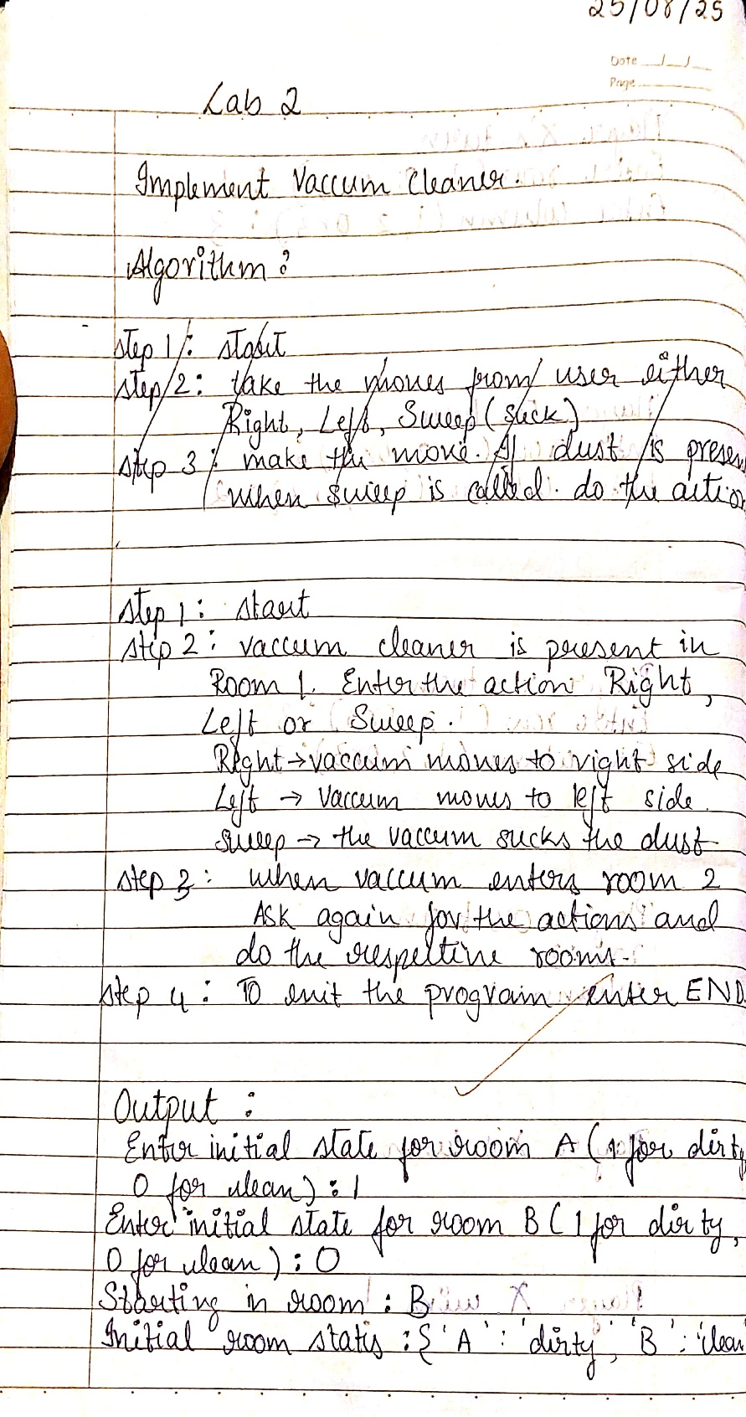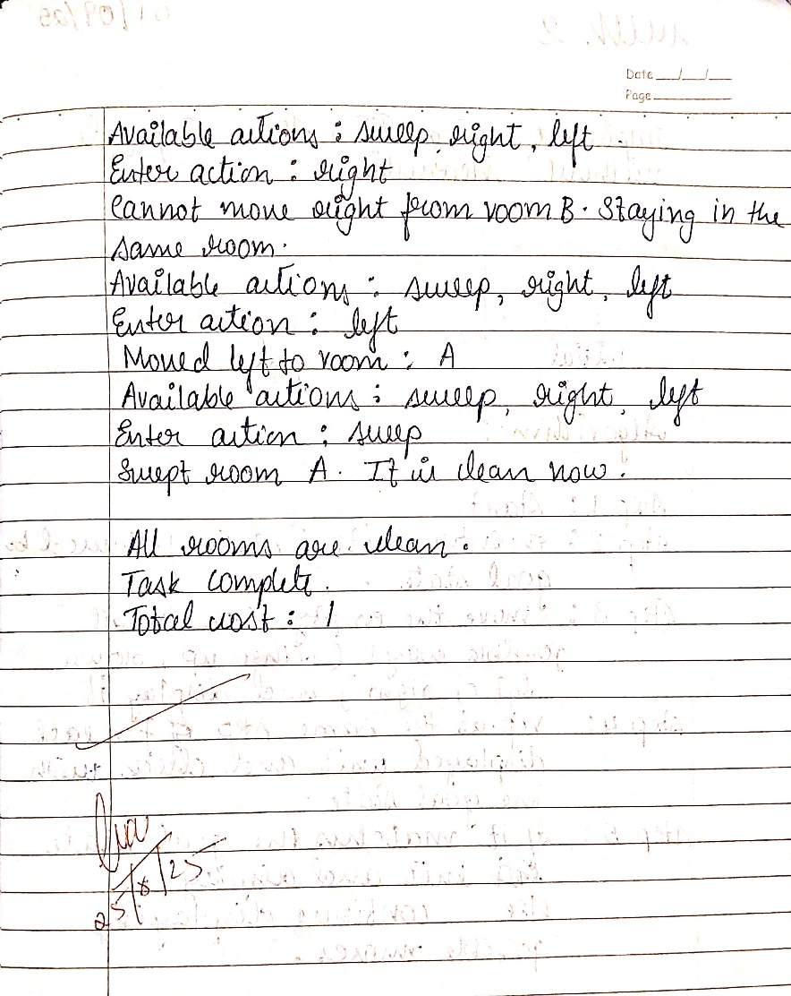
#week 1 VACCUM CLEANER
import random

class VacuumCleanerAgent:
def __init__(self, rooms):
self.rooms = rooms
self.current_room = random.choice(list(rooms.keys()))
self.cost = 0
print(f"Starting in room: {self.current_room}")
print(f"Initial room states: {self.rooms}")

def sweep(self):
if self.rooms[self.current_room] == 'dirty':
self.rooms[self.current_room] = 'clean'
self.cost += 1 # Increment cost for sweeping
print(f"Swept room {self.current_room}. It is now clean.")
return True
else:
print(f"Room {self.current_room} is already clean.")
return False

def right(self):
room_names = list(self.rooms.keys())
current_index = room_names.index(self.current_room)
if current_index < len(room_names) - 1:
self.current_room = room_names[current_index + 1]
print(f"Moved right to room: {self.current_room}")
else:
print(f"Cannot move right from room {self.current_room}. Staying in the same room.")

def left(self):
room_names = list(self.rooms.keys())
current_index = room_names.index(self.current_room)
if current_index > 0:
self.current_room = room_names[current_index - 1]
print(f"Moved left to room: {self.current_room}")
else:
print(f"Cannot move left from room {self.current_room}. Staying in the same room.")

def perceive(self):
return self.rooms[self.current_room]

initial_states = {}
for room in rooms.keys():
while True:
state = input(f"Enter initial state for room {room} (1 for dirty, 0 for clean): ")
if state == '1':
initial_states[room] = 'dirty'
break
elif state == '0':
initial_states[room] = 'clean'
break
else:
print("Invalid input. Please enter 1 or 0.")

agent = VacuumCleanerAgent(initial_states)
while any(status == 'dirty' for status in agent.rooms.values()):
print("\nAvailable actions: sweep, right, left")
action = input("Enter action: ").lower()

if action == 'sweep':
agent.sweep()
elif action == 'right':
agent.right()
elif action == 'left':
agent.left()
else:
print("Invalid action. Please enter sweep, right, or left.")

print("\nAll rooms are clean. Task complete.")
print(f"Total cost: {agent.cost}")
print("Sameksha 1BM23CS292")

output:

Enter initial state for room A (1 for dirty, 0 for clean): 1
Enter initial state for room B (1 for dirty, 0 for clean): 0
Starting in room: B
Initial room states: {'A': 'dirty', 'B': 'clean'}

Available actions: sweep, right, left
Enter action: right
Cannot move right from room B. Staying in the same room.

Available actions: sweep, right, left
Enter action: left
Moved left to room: A

Available actions: sweep, right, left
Enter action: left
Cannot move left from room A. Staying in the same room.

Available actions: sweep, right, left
Enter action: sweep
Swept room A. It is now clean.

All rooms are clean. Task complete.
Total cost: 1
Sameksha 1BM23CS292

PROGRAM 2
Implement 8 puzzle problems using Depth First Search (DFS)

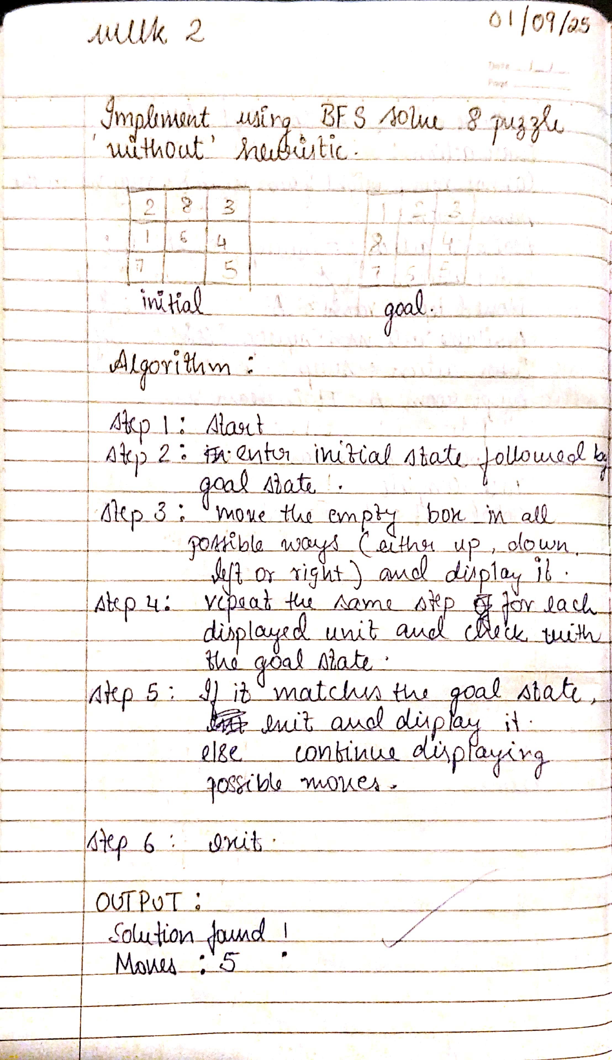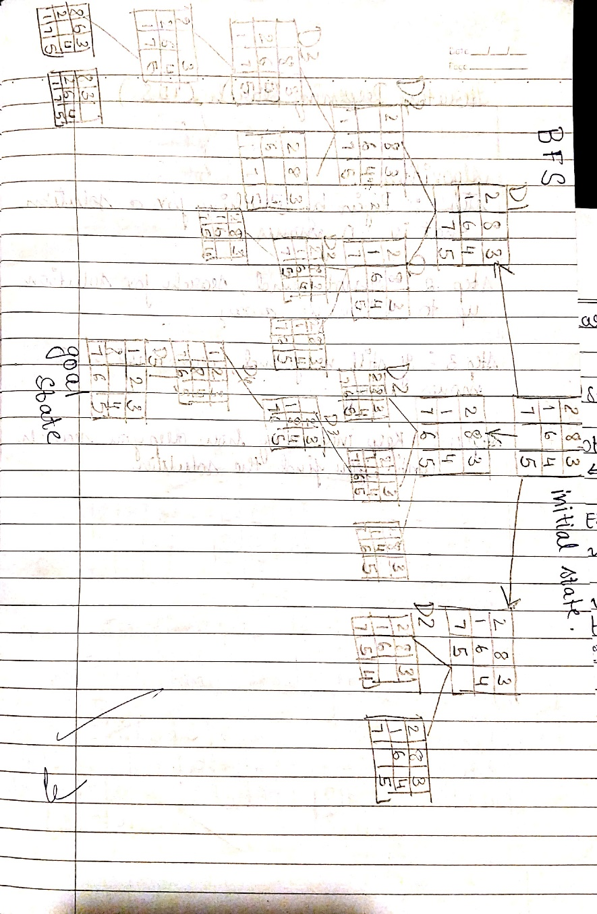

#WEEK2 8PUZZLE PPROBLEM in BFS
from collections import deque

goal_state = '123804765'
# Using '0' as the empty space

# Moves: U, D, L, R (Up, Down, Left, Right)
moves = {
'U': -3,
'D': 3,
'L': -1,
'R': 1
}

# Valid moves for each index to prevent wrapping around rows/columns
invalid_moves = {
0: ['U', 'L'], 1: ['U'], 2: ['U', 'R'],
3: ['L'], 5: ['R'],
6: ['D', 'L'], 7: ['D'], 8: ['D', 'R']
}

# Function to generate new puzzle state after moving the blank
def move_tile(state, direction):
index = state.index('0')
if direction in invalid_moves.get(index, []):
return None

new_index = index + moves[direction]
if new_index < 0 or new_index >= 9:
return None

state_list = list(state)
# Swap 0 with the target tile
state_list[index], state_list[new_index] = state_list[new_index], state_list[index]
return ''.join(state_list)

# Helper function to print the state in 3x3 format
def print_state(state):
for i in range(0, 9, 3):
# Replace '0' with space for readability
print(' '.join(state[i:i+3]).replace('0', ' '))
print() # Blank line for spacing

# BFS Algorithm with printing all visited states
def bfs(start_state):
visited = set()
queue = deque([(start_state, [])]) # Each element is (state, path)

while queue:
current_state, path = queue.popleft()

if current_state in visited:
continue

# Print each visited state
print("Visited state:")
print_state(current_state)

if current_state == goal_state:
return path

visited.add(current_state)

for direction in moves:
new_state = move_tile(current_state, direction)
if new_state and new_state not in visited:
queue.append((new_state, path + [direction]))

return None # No solution found

# Input initial state as a string (e.g., '123456780' where 0 is the blank)
start = input("Enter the INITIAL state (give '0'for empty space): ")

if len(start) == 9 and set(start) == set('012345678'):
print("INITIAL state:")
print_state(start)

result = bfs(start)

if result is not None:
print("Solution found!")
print("Moves:", ' '.join(result))
print("Number of moves:", len(result))
current_state = start
for i, move in enumerate(result, 1):
current_state = move_tile(current_state, move)
print(f"Move {i}: {move}")
print_state(current_state)
else:
print("No solution exists for the given start state.")
else:
print("Invalid input! Please enter a 9-digit string using digits 0-8 without repetition.")
print("1BM23CS292 Sameksha\n")

OUTPUT:
Enter the INITIAL state (give '0'for empty space): 283164705
INITIAL state:
2 8 3
1 6 4
7 5

Visited state:
2 8 3
1 6 4
7 5

Visited state:
2 8 3
1 4
7 6 5

Visited state:
2 8 3
1 6 4
7 5

Visited state:
2 8 3
1 6 4
7 5

Visited state:
2 3
1 8 4
7 6 5

Visited state:
2 8 3
1 4
7 6 5

Visited state:
2 8 3
1 4
7 6 5

Visited state:
2 8 3
6 4
1 7 5

Visited state:
2 8 3
1 6
7 5 4

Visited state:
2 3
1 8 4
7 6 5

Visited state:
2 3
1 8 4
7 6 5

Visited state:
8 3
2 1 4
7 6 5

Visited state:
2 8 3
7 1 4
6 5

Visited state:
2 8
1 4 3
7 6 5

Visited state:
2 8 3
1 4 5
7 6

Visited state:
8 3
2 6 4
1 7 5

Visited state:
2 8 3
6 4
1 7 5

Visited state:
2 8
1 6 3
7 5 4

Visited state:
2 8 3
1 6
7 5 4

Visited state:
1 2 3
8 4
7 6 5

Visited state:
2 3 4
1 8
7 6 5

Visited state:
8 3
2 1 4
7 6 5

Visited state:
2 8 3
7 1 4
6 5

Visited state:
2 8
1 4 3
7 6 5

Visited state:
2 8 3
1 4 5
7 6

Visited state:
8 3
2 6 4
1 7 5

Visited state:
2 3
6 8 4
1 7 5

Visited state:
2 8 3
6 7 4
1 5

Visited state:
2 8 3
6 4
1 7 5

Visited state:
2 8
1 6 3
7 5 4

Visited state:
2 3
1 8 6
7 5 4

Visited state:
2 8 3
1 5 6
7 4

Visited state:
2 8 3
1 6
7 5 4

Visited state:
1 2 3
7 8 4
6 5

Visited state:
1 2 3
8 4
7 6 5

Solution found!
Moves: U U L D R
Number of moves: 5
Move 1: U
2 8 3
1 4
7 6 5

Move 2: U
2 3
1 8 4
7 6 5

Move 3: L
2 3
1 8 4
7 6 5

Move 4: D
1 2 3
8 4
7 6 5

Move 5: R
1 2 3
8 4
7 6 5

1BM23CS292 Sameksha

Implement Iterative deepening search algorithm
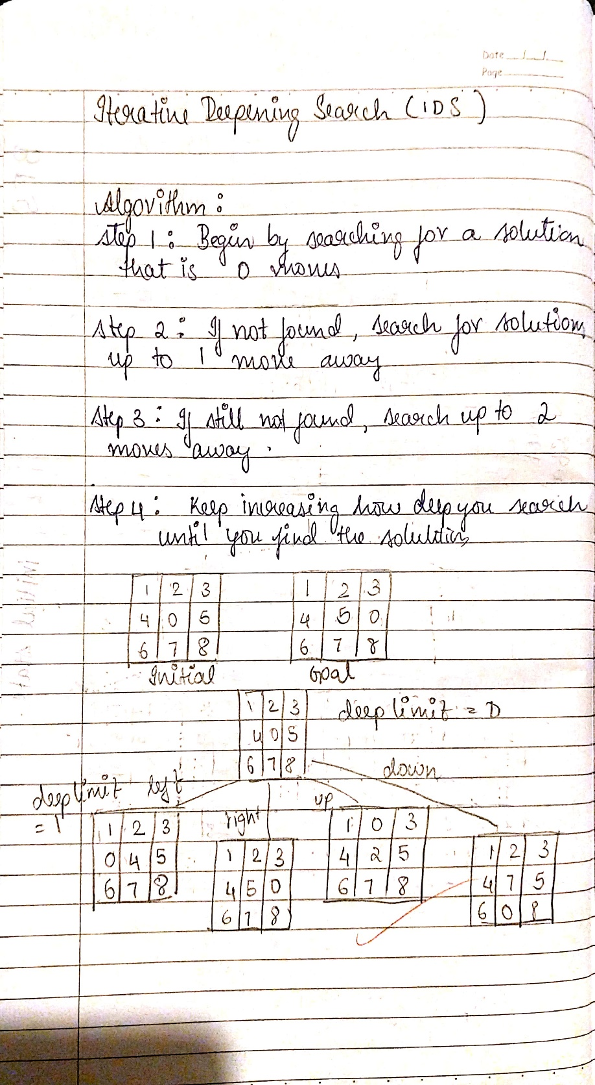

#WEEK2 8PUZZLE PPROBLEM in DFS
goal_state = '123804765'

moves = {
'U': -3,
'D': 3,
'L': -1,
'R': 1
}

invalid_moves = {
0: ['U', 'L'], 1: ['U'], 2: ['U', 'R'],
3: ['L'], 5: ['R'],
6: ['D', 'L'], 7: ['D'], 8: ['D', 'R']
}

def move_tile(state, direction):
index = state.index('0')
if direction in invalid_moves.get(index, []):
return None

new_index = index + moves[direction]
if new_index < 0 or new_index >= 9:
return None

state_list = list(state)
state_list[index], state_list[new_index] = state_list[new_index], state_list[index]
return ''.join(state_list)

def print_state(state):
for i in range(0, 9, 3):
print(' '.join(state[i:i+3]).replace('0', ' '))
print()

def dfs(start_state, max_depth=50):
visited = set()
stack = [(start_state, [])] # Each element: (state, path)

while stack:
current_state, path = stack.pop()

if current_state in visited:
continue

# Print every visited state
print("Visited state:")
print_state(current_state)

if current_state == goal_state:
return path

visited.add(current_state)

if len(path) >= max_depth:
continue

for direction in moves:
new_state = move_tile(current_state, direction)
if new_state and new_state not in visited:
stack.append((new_state, path + [direction]))

return None

start = input("Enter the INITIAL state (give '0'for empty space): ")

if len(start) == 9 and set(start) == set('012345678'):
print("INITIAL state:")
print_state(start)

result = dfs(start)

if result is not None:
print("Solution found!")
print("Moves:", ' '.join(result))
print("Number of moves:", len(result))

current_state = start
for i, move in enumerate(result, 1):
current_state = move_tile(current_state, move)
print(f"Move {i}: {move}")
print_state(current_state)
else:
print("No solution exists for the given start state or max depth reached.")
else:
print("Invalid input! Please enter a 9-digit string using digits 0-8 without repetition.")

print("1BM23CS292 Sameksha")

PROGRAM 3
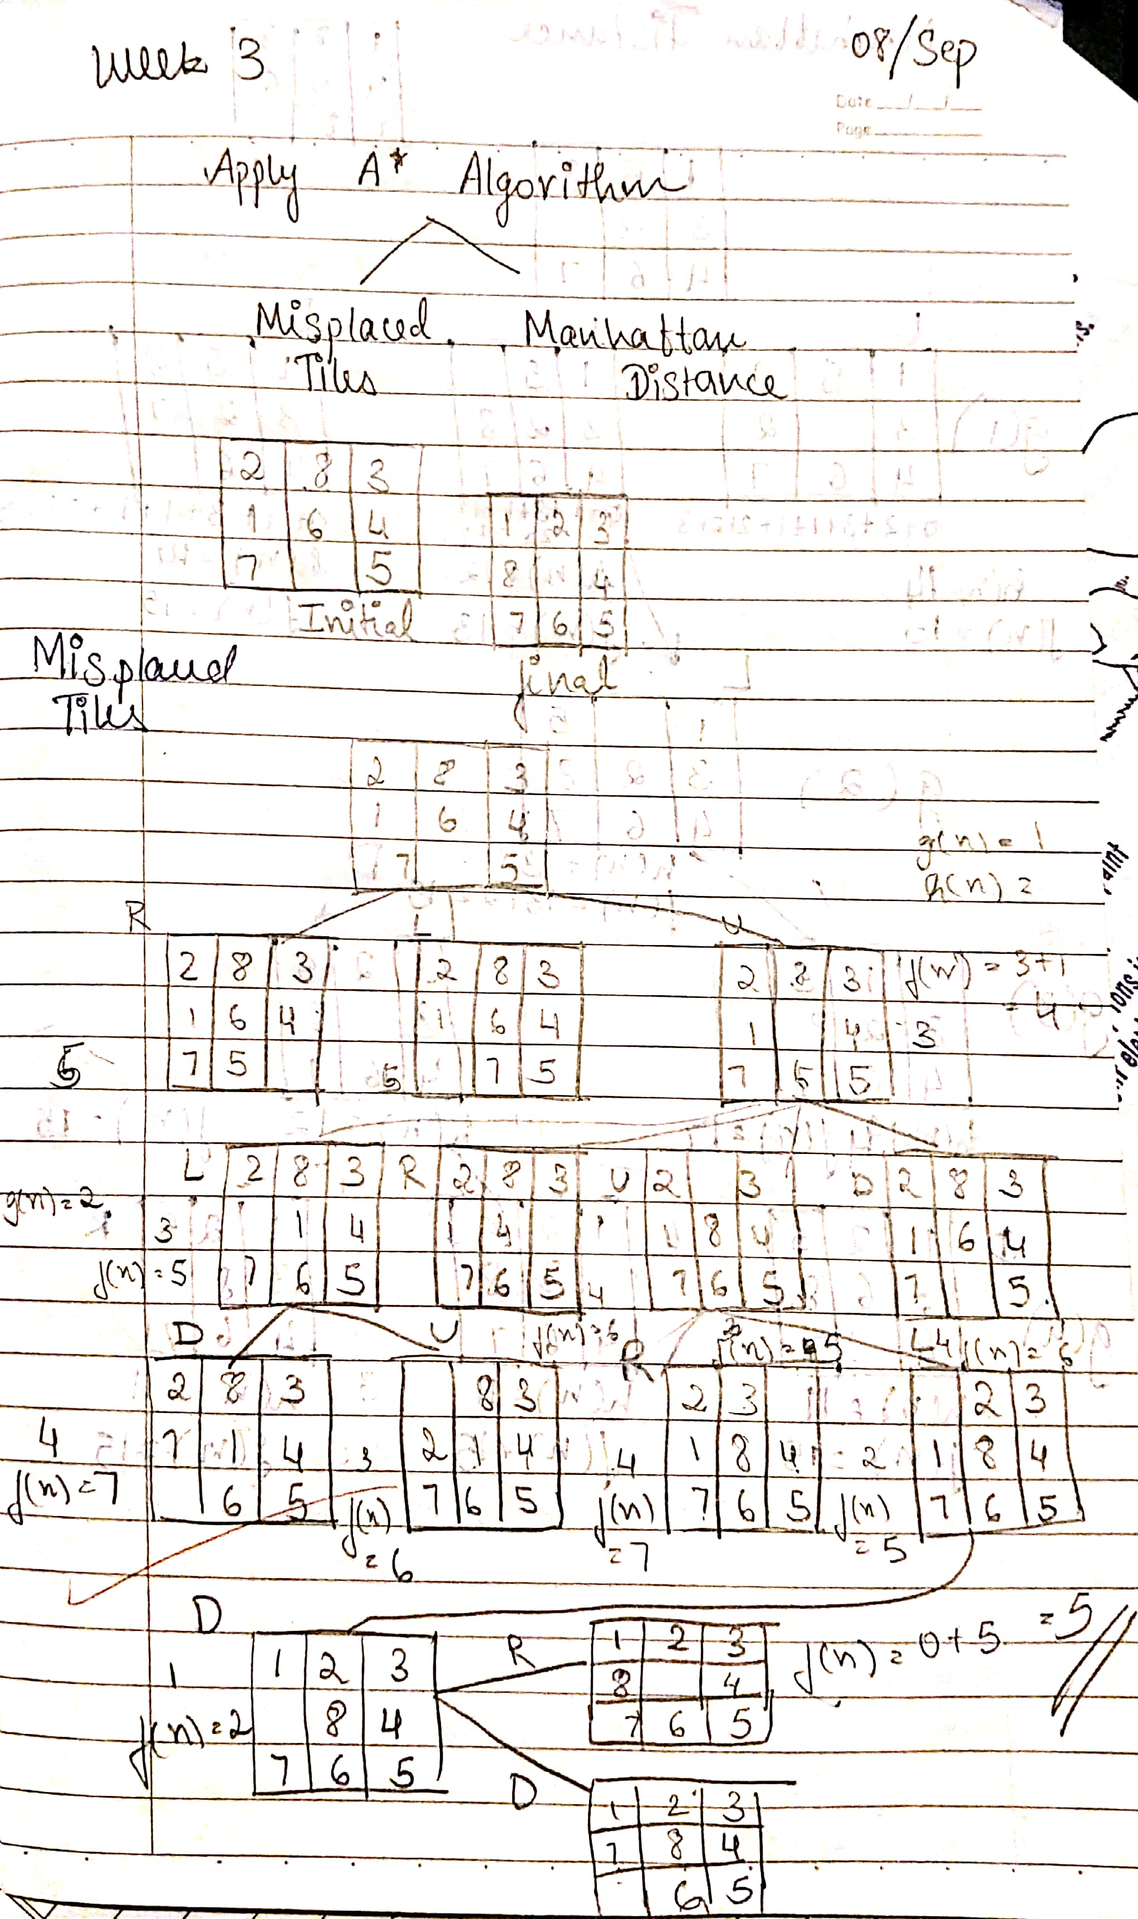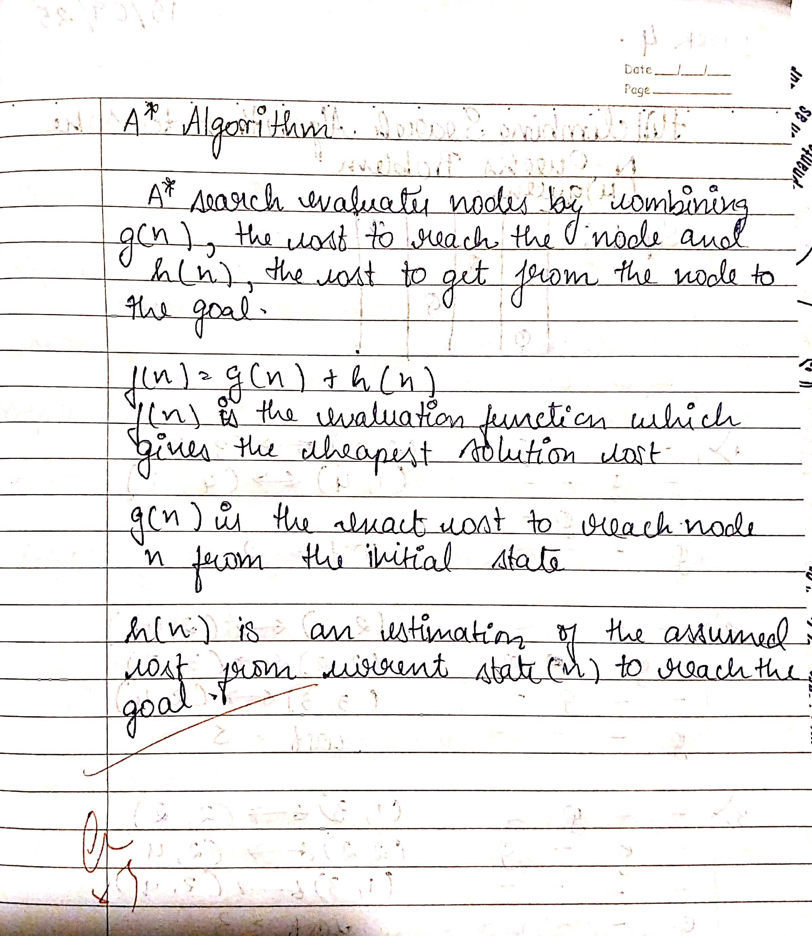

#misplaces tiles A*technique
#WEEK 3
import heapq

goal_state = '123804765'

moves = {
'U': -3,
'D': 3,
'L': -1,
'R': 1
}

invalid_moves = {
0: ['U', 'L'], 1: ['U'], 2: ['U', 'R'],
3: ['L'], 5: ['R'],
6: ['D', 'L'], 7: ['D'], 8: ['D', 'R']
}

def move_tile(state, direction):
index = state.index('0')
if direction in invalid_moves.get(index, []):
return None

new_index = index + moves[direction]
if new_index < 0 or new_index >= 9:
return None

state_list = list(state)
state_list[index], state_list[new_index] = state_list[new_index], state_list[index]
return ''.join(state_list)

def print_state(state):
for i in range(0, 9, 3):
print(' '.join(state[i:i+3]).replace('0', ' '))
print()

def misplaced_tiles(state):
"""Heuristic: count of tiles not in their goal position (excluding zero)."""
return sum(1 for i, val in enumerate(state) if val != '0' and val != goal_state[i])

def a_star(start_state):
visited_count = 0
open_set = []
heapq.heappush(open_set, (misplaced_tiles(start_state), 0, start_state, []))
visited = set()

while open_set:
f, g, current_state, path = heapq.heappop(open_set)
visited_count += 1

if current_state == goal_state:
return path, visited_count

if current_state in visited:
continue
visited.add(current_state)

for direction in moves:
new_state = move_tile(current_state, direction)
if new_state and new_state not in visited:
new_g = g + 1
new_f = new_g + misplaced_tiles(new_state)
heapq.heappush(open_set, (new_f, new_g, new_state, path + [direction]))

return None, visited_count

# Main
start = input("Enter start state (e.g., 724506831): ")

if len(start) == 9 and set(start) == set('012345678'):
print("Start state:")
print_state(start)

result, visited_states = a_star(start)

print(f"Total states visited: {visited_states}")

if result is not None:
print("Solution found!")
print("Moves:", ' '.join(result))
print("Number of moves:", len(result))
print("SAMEKSHA 1BM23CS292\n")

current_state = start
for i, move in enumerate(result, 1):
current_state = move_tile(current_state, move)
print(f"Move {i}: {move}")
print_state(current_state)
else:
print("No solution exists for the given start state.")
else:
print("Invalid input! Please enter a 9-digit string using digits 0-8 without repetition.")

output:
Enter start state (e.g., 724506831): 124305678
Start state:
1 2 4
3 5
6 7 8

Total states visited: 789
Solution found!
Moves: L U R D D R U U L L D R D L U R
Number of moves: 16
SAMEKSHA 1BM23CS292

Move 1: L
1 2 4
3 5
6 7 8

Move 2: U
2 4
1 3 5
6 7 8

Move 3: R
2 4
1 3 5
6 7 8

Move 4: D
2 3 4
1 5
6 7 8

Move 5: D
2 3 4
1 7 5
6 8

Move 6: R
2 3 4
1 7 5
6 8

Move 7: U
2 3 4
1 7
6 8 5

Move 8: U
2 3
1 7 4
6 8 5

Move 9: L
2 3
1 7 4
6 8 5

Move 10: L
2 3
1 7 4
6 8 5

Move 11: D
1 2 3
7 4
6 8 5

Move 12: R
1 2 3
7 4
6 8 5

Move 13: D
1 2 3
7 8 4
6 5

Move 14: L
1 2 3
7 8 4
6 5

Move 15: U
1 2 3
8 4
7 6 5

Move 16: R
1 2 3
8 4
7 6 5

Program 4
Implement Hill Climbing search algorithm and Hill climbing algorithm
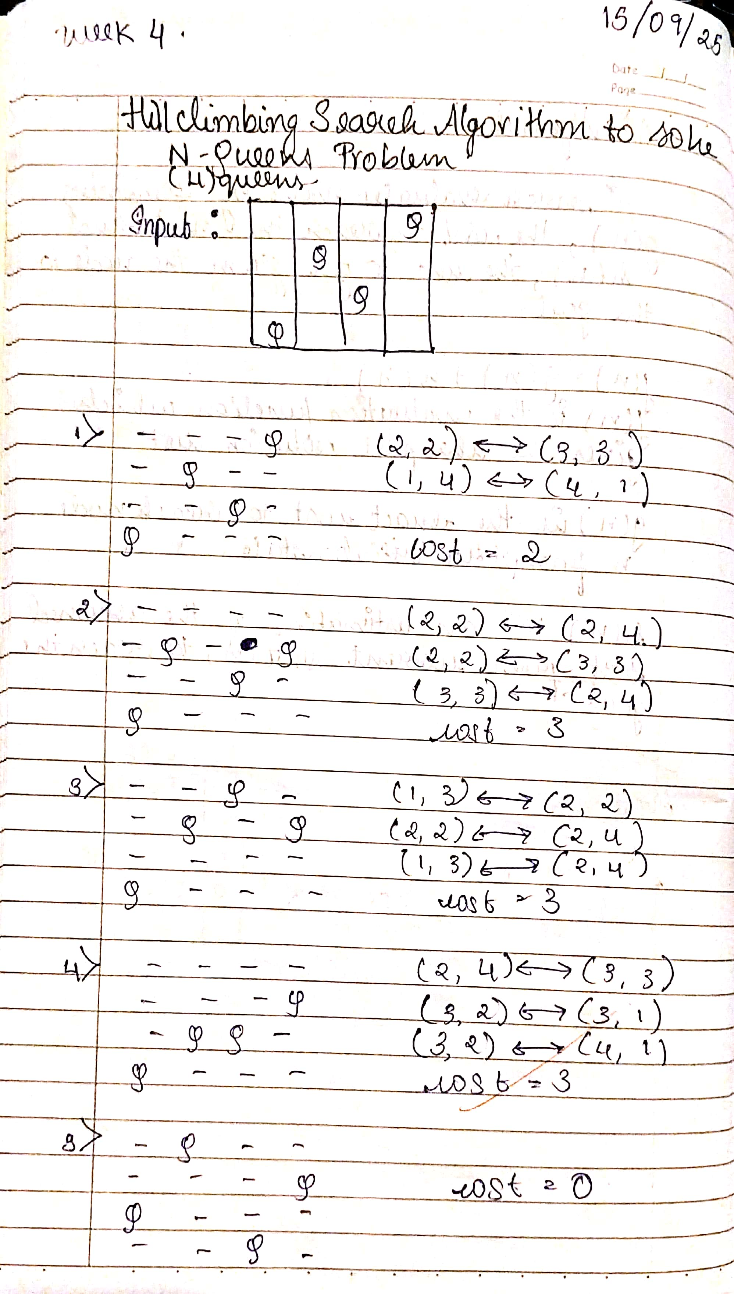
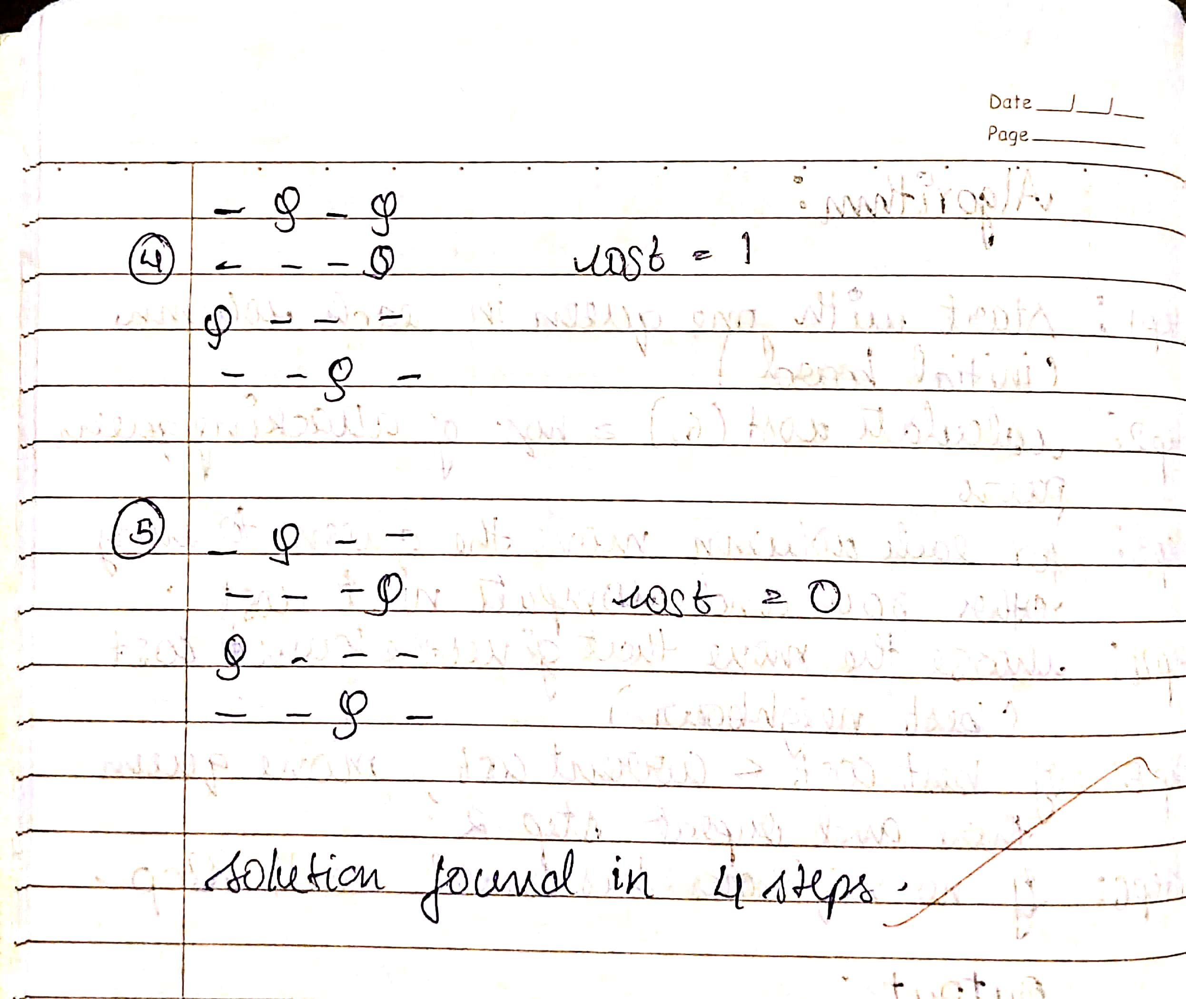
Code:
import random
import time

def print_board(state):
"""Prints the chessboard for a given state."""
n = len(state)
for row in range(n):
line = ""
for col in range(n):
if state[col] == row:
line += "Q "
else:
line += ". "
print(line)
print()

def compute_heuristic(state):
"""Computes the number of attacking pairs of queens."""
h = 0
n = len(state)
for i in range(n):
for j in range(i + 1, n):
if state[i] == state[j] or abs(state[i] - state[j]) == abs(i - j):
h += 1
return h

def get_neighbors(state):
"""Generates all possible neighbors by moving one queen in its column."""
neighbors = []
n = len(state)
for col in range(n):
for row in range(n):
if row != state[col]:
neighbor = list(state)
neighbor[col] = row
neighbors.append(neighbor)
return neighbors

def hill_climb_verbose(initial_state, step_delay=0.5):
"""Hill climbing algorithm with verbose output at each step."""
current = initial_state
current_h = compute_heuristic(current)
step = 0

print(f"Initial state (heuristic: {current_h}):")
print_board(current)
time.sleep(step_delay)

while True:
neighbors = get_neighbors(current)
next_state = None
next_h = current_h

for neighbor in neighbors:
h = compute_heuristic(neighbor)
if h < next_h:
next_state = neighbor
next_h = h

if next_h >= current_h:
print(f"Reached local minimum at step {step}, heuristic: {current_h}")
return current, current_h

current = next_state
current_h = next_h
step += 1
print(f"Step {step}: (heuristic: {current_h})")
print_board(current)
time.sleep(step_delay)

def solve_n_queens_verbose(n, max_restarts=1000):
"""Solves N-Queens problem using hill climbing with restarts and verbose output."""
for attempt in range(max_restarts):
print(f"\n=== Restart {attempt + 1} ===\n")
initial_state = [random.randint(0, n - 1) for _ in range(n)]
solution, h = hill_climb_verbose(initial_state)
if h == 0:
print(f"✅ Solution found after {attempt + 1} restart(s):")
print_board(solution)
return solution
else:
print(f"❌ No solution in this attempt (local minimum).\n")
print("Failed to find a solution after max restarts.")
return None

# --- Run the algorithm ---
if __name__ == "__main__":
N = int(input("Enter the number of queens (N): "))
solve_n_queens_verbose(N)
print("1BM23CS292 sameksha")
output:
Enter the number of queens (N): 4

=== Restart 1 ===

Initial state (heuristic: 4):
. . . .
. . Q Q
. Q . .
Q . . .

Step 1: (heuristic: 2)
Q . . .
. . Q Q
. Q . .
. . . .

Step 2: (heuristic: 1)
Q . . .
. . . Q
. Q . .
. . Q .

Reached local minimum at step 2, heuristic: 1
❌ No solution in this attempt (local minimum).

=== Restart 2 ===

Initial state (heuristic: 3):
. . . .
. Q Q .
. . . Q
Q . . .

Step 1: (heuristic: 1)
. . Q .
. Q . .
. . . Q
Q . . .

Reached local minimum at step 1, heuristic: 1
❌ No solution in this attempt (local minimum).

=== Restart 3 ===

Initial state (heuristic: 4):
. . Q Q
. . . .
Q Q . .
. . . .

Step 1: (heuristic: 2)
. . Q .
. . . .
Q Q . .
. . . Q

Step 2: (heuristic: 1)
. . Q .
Q . . .
. Q . .
. . . Q

Reached local minimum at step 2, heuristic: 1
❌ No solution in this attempt (local minimum).

=== Restart 4 ===

Initial state (heuristic: 3):
Q . . Q
. . . .
. . Q .
. Q . .

Step 1: (heuristic: 1)
. . . Q
Q . . .
. . Q .
. Q . .

Reached local minimum at step 1, heuristic: 1
❌ No solution in this attempt (local minimum).

=== Restart 5 ===

Initial state (heuristic: 5):
. . . .
. . . .
Q . Q Q
. Q . .

Step 1: (heuristic: 2)
. . . .
Q . . .
. . Q Q
. Q . .

Step 2: (heuristic: 0)
. . Q .
Q . . .
. . . Q
. Q . .

Reached local minimum at step 2, heuristic: 0
✅ Solution found after 5 restart(s):
. . Q .
Q . . .
. . . Q
. Q . .

1BM23CS292 sameksha

Problem 5
Simulated Annealing to Solve 8-Queens problem

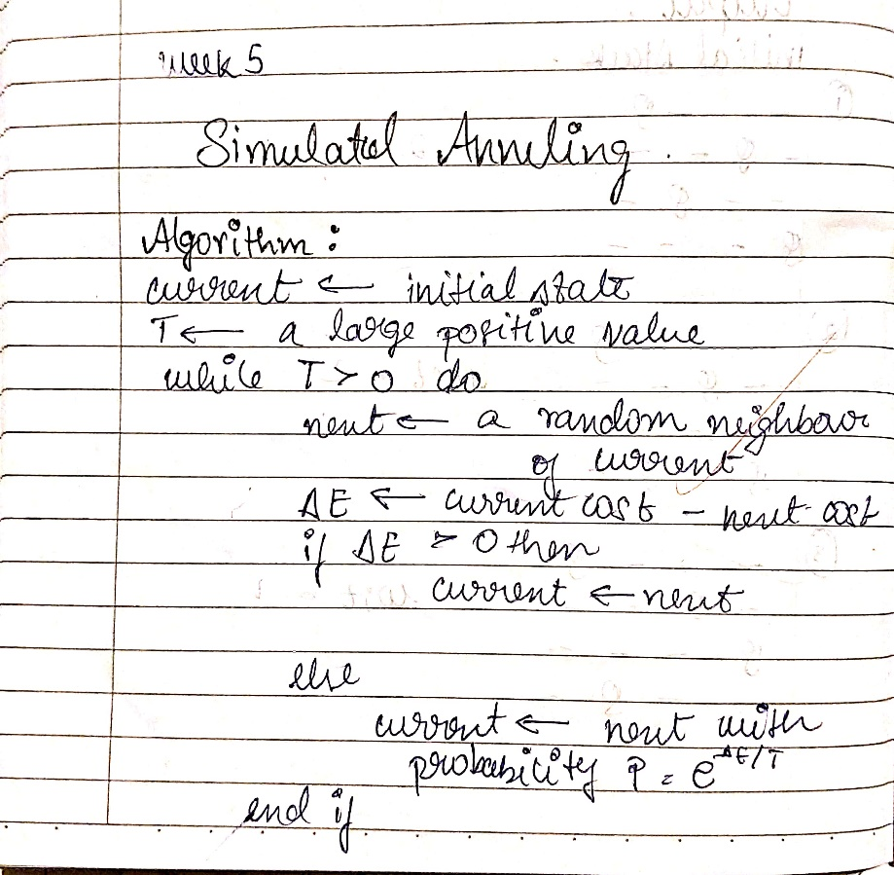
Code:
#WEEK 5
import random
import math

def compute_heuristic(state):
"""Number of attacking pairs."""
h = 0
n = len(state)
for i in range(n):
for j in range(i + 1, n):
if state[i] == state[j] or abs(state[i] - state[j]) == abs(i - j):
h += 1
return h

def random_neighbor(state):
"""Returns a neighbor by randomly changing one queen's row."""
n = len(state)
neighbor = state[:]
col = random.randint(0, n - 1)
old_row = neighbor[col]
new_row = random.choice([r for r in range(n) if r != old_row])
neighbor[col] = new_row
return neighbor

def dual_simulated_annealing(n, max_iter=10000, initial_temp=100.0, cooling_rate=0.99):
"""Simulated Annealing with dual acceptance strategy."""
current = [random.randint(0, n - 1) for _ in range(n)]
current_h = compute_heuristic(current)
temperature = initial_temp

for step in range(max_iter):
if current_h == 0:
print(f"✅ Solution found at step {step}")
return current

neighbor = random_neighbor(current)
neighbor_h = compute_heuristic(neighbor)
delta = neighbor_h - current_h

if delta < 0:
current = neighbor
current_h = neighbor_h
else:
# Dual acceptance: standard + small chance of higher uphill move
probability = math.exp(-delta / temperature)
if random.random() < probability:
current = neighbor
current_h = neighbor_h

temperature *= cooling_rate
if temperature < 1e-5: # Restart if stuck
temperature = initial_temp
current = [random.randint(0, n - 1) for _ in range(n)]
current_h = compute_heuristic(current)

print("❌ Failed to find solution within max iterations.")
return None

# --- Run the algorithm ---
if __name__ == "__main__":
N = int(input("Enter number of queens (N): "))
solution = dual_simulated_annealing(N)

if solution:
print("Position format:")
print("[", " ".join(str(x) for x in solution), "]")
print("Heuristic:", compute_heuristic(solution))
print("1BM23CS292 sameksha")

output:
Enter number of queens (N): 4
✅ Solution found at step 18
Position format:
[ 1 3 0 2 ]
Heuristic: 0
1BM23CS292 sameksha

Program 6
Create a knowledge base using propositional logic and show that the given query entails the knowledge base or not
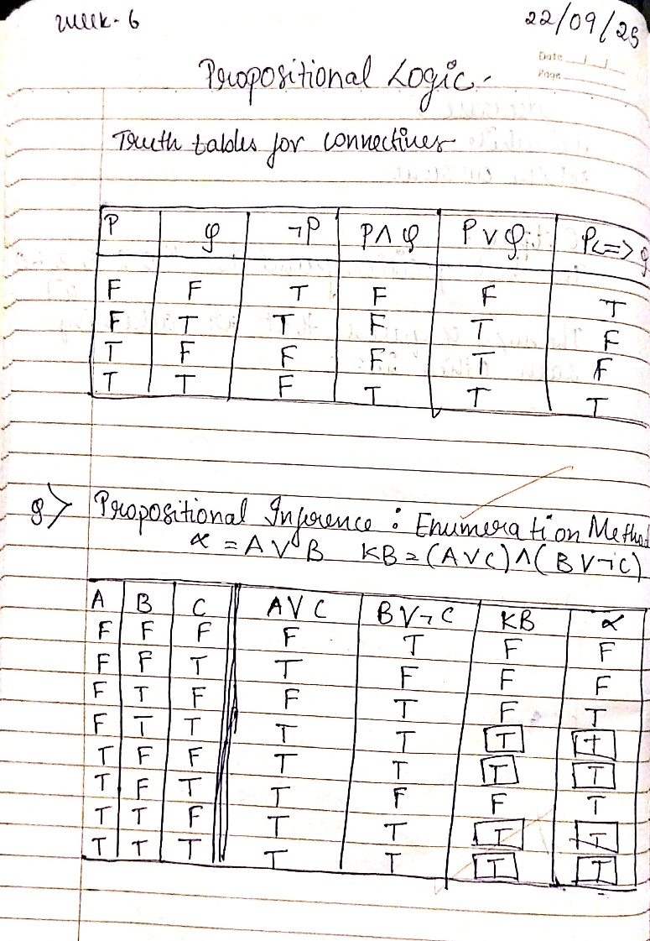
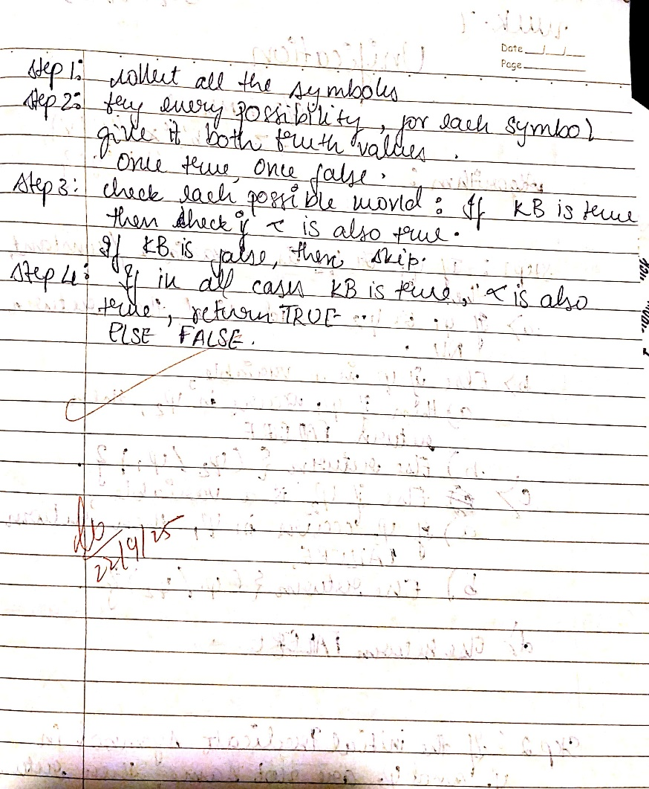
Code:
#WEEK7
import itertools
import pandas as pd
from tabulate import tabulate
import re

# Helper: convert booleans to T/F
def tf(val):
return "T" if val else "F"

# Replace logical symbols (∨, ∧, ¬) with Python equivalents
def translate(expr: str) -> str:
return (
expr.replace("∨", " or ")
.replace("∧", " and ")
.replace("¬", " not ")
)

# === Take KB and α (query) from user ===
kb_expr = input("Enter your Knowledge Base (use ∧, ∨, ¬): ")
alpha_expr = input("Enter your α (query) (use ∧, ∨, ¬): ")

# Translate to Python syntax
kb_py = translate(kb_expr)
alpha_py = translate(alpha_expr)

# === Detect variables dynamically (any single letter, uppercase/lowercase) ===
vars_in_expr = sorted(set(re.findall(r"\b[a-zA-Z]\b", kb_expr + alpha_expr)))

if not vars_in_expr:
raise ValueError("No variables detected. Please use single letters like A, b, C...")

# Generate truth table
rows = []
for values in itertools.product([False, True], repeat=len(vars_in_expr)):
local_vars = dict(zip(vars_in_expr, values))
kb_val = eval(kb_py, {}, local_vars)
alpha_val = eval(alpha_py, {}, local_vars)

row = {var: tf(val) for var, val in local_vars.items()}
row["KB"] = tf(kb_val)
row[f"α = {alpha_expr}"] = tf(alpha_val)
rows.append(row)

# Convert to DataFrame
df = pd.DataFrame(rows)

# Full truth table
print("\n=== Full Truth Table ===")
print(tabulate(df, headers="keys", tablefmt="fancy_grid", showindex=False))

# Filtered truth table (only KB = T)
filtered_df = df[df["KB"] == "T"]

print("\n=== Rows where KB is True ===")
if not filtered_df.empty:
print(tabulate(filtered_df, headers="keys", tablefmt="fancy_grid", showindex=False))
else:
print("No rows where KB is True (KB is unsatisfiable).")

# Entailment check
query_col = f"α = {alpha_expr}"
entails = all(filtered_df[query_col] == "T") if not filtered_df.empty else True
print(f"\nDoes KB entail α ({alpha_expr})? ->", "Yes" if entails else "No")
print("SAMEIKSHA 1BM23CS292\n")

output:
Enter your Knowledge Base (use ∧, ∨, ¬): (a ∨ c) ∧ (b ∨ ¬c)
Enter your α (query) (use ∧, ∨, ¬): a ∨ b

=== Full Truth Table ===
╒═════╤═════╤═════╤══════╤═════════════╕
│ a │ b │ c │ KB │ α = a ∨ b │
╞═════╪═════╪═════╪══════╪═════════════╡
│ F │ F │ F │ F │ F │
├─────┼─────┼─────┼──────┼─────────────┤
│ F │ F │ T │ F │ F │
├─────┼─────┼─────┼──────┼─────────────┤
│ F │ T │ F │ F │ T │
├─────┼─────┼─────┼──────┼─────────────┤
│ F │ T │ T │ T │ T │
├─────┼─────┼─────┼──────┼─────────────┤
│ T │ F │ F │ T │ T │
├─────┼─────┼─────┼──────┼─────────────┤
│ T │ F │ T │ F │ T │
├─────┼─────┼─────┼──────┼─────────────┤
│ T │ T │ F │ T │ T │
├─────┼─────┼─────┼──────┼─────────────┤
│ T │ T │ T │ T │ T │
╘═════╧═════╧═════╧══════╧═════════════╛

=== Rows where KB is True ===
╒═════╤═════╤═════╤══════╤═════════════╕
│ a │ b │ c │ KB │ α = a ∨ b │
╞═════╪═════╪═════╪══════╪═════════════╡
│ F │ T │ T │ T │ T │
├─────┼─────┼─────┼──────┼─────────────┤
│ T │ F │ F │ T │ T │
├─────┼─────┼─────┼──────┼─────────────┤
│ T │ T │ F │ T │ T │
├─────┼─────┼─────┼──────┼─────────────┤
│ T │ T │ T │ T │ T │
╘═════╧═════╧═════╧══════╧═════════════╛

Does KB entail α (a ∨ b)? -> Yes
SAMEIKSHA 1BM23CS292

Program 8
Unification using FOL

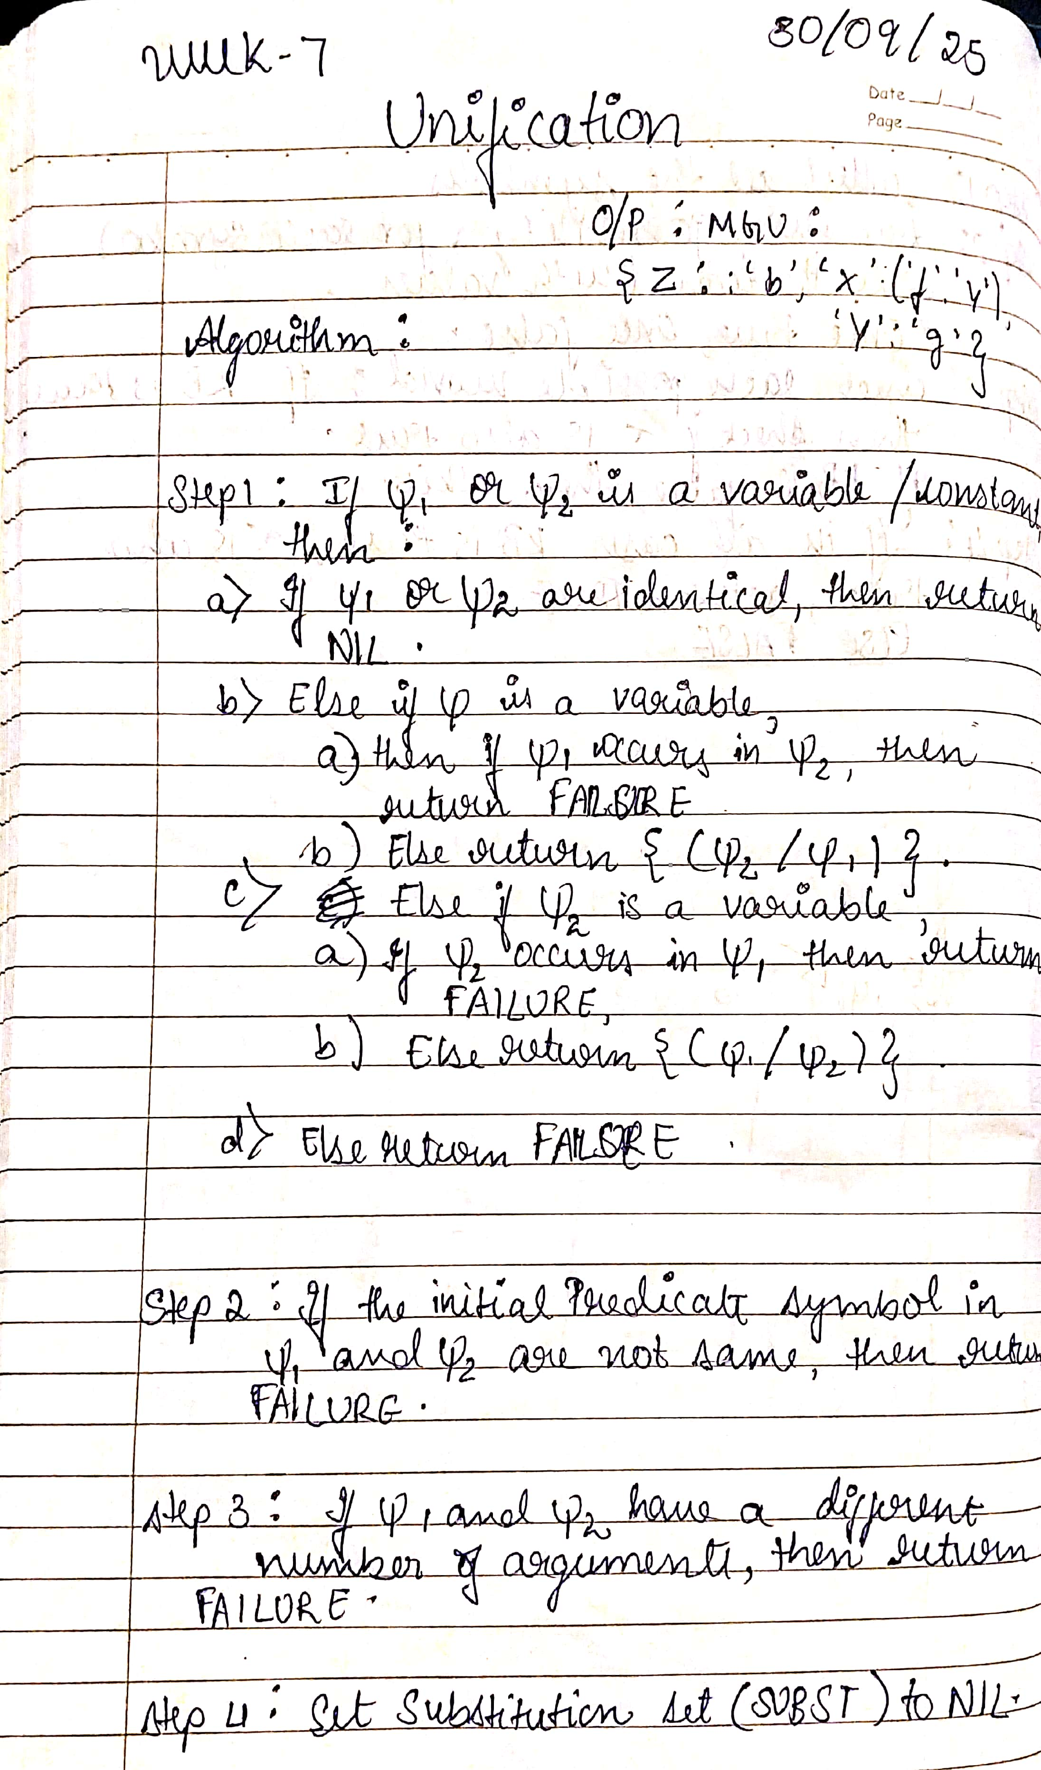
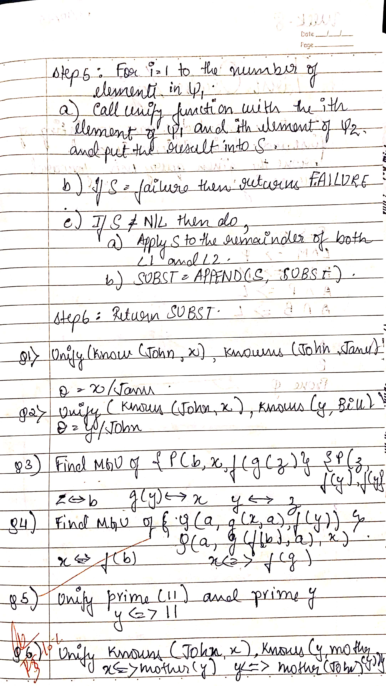
Code:
class UnificationError(Exception):
pass

def occurs_check(var, term):
"""Check if a variable occurs in a term (to prevent infinite recursion)."""
if var == term:
return True
if isinstance(term, tuple): # Term is a compound (function term)
return any(occurs_check(var, subterm) for subterm in term)
return False

def unify(term1, term2, substitutions=None):
"""Try to unify two terms, return the MGU (Most General Unifier)."""
if substitutions is None:
substitutions = {}

# If both terms are equal, no further substitution is needed
if term1 == term2:
return substitutions

# If term1 is a variable, we substitute it with term2
elif isinstance(term1, str) and term1.isupper():
# If term1 is already substituted, recurse
if term1 in substitutions:
return unify(substitutions[term1], term2, substitutions)
elif occurs_check(term1, term2):
raise UnificationError(f"Occurs check fails: {term1} in {term2}")
else:
substitutions[term1] = term2
return substitutions

# If term2 is a variable, we substitute it with term1
elif isinstance(term2, str) and term2.isupper():
# If term2 is already substituted, recurse
if term2 in substitutions:
return unify(term1, substitutions[term2], substitutions)
elif occurs_check(term2, term1):
raise UnificationError(f"Occurs check fails: {term2} in {term1}")
else:
substitutions[term2] = term1
return substitutions

# If both terms are compound (i.e., functions), unify their parts recursively
elif isinstance(term1, tuple) and isinstance(term2, tuple):
# Ensure that both terms have the same "functor" and number of arguments
# if len(term1) != len(term2):
# raise UnificationError(f"Function arity mismatch: {term1} vs {term2}")

for subterm1, subterm2 in zip(term1, term2):
substitutions = unify(subterm1, subterm2, substitutions)

return substitutions

else:
raise UnificationError(f"Cannot unify: {term1} with {term2}")

# Define the terms as tuples
term1 = ('p', 'b', 'X', ('f', ('g', 'Z')))
term2 = ('p', 'Z', ('f', 'Y'), ('f', 'Y'))

try:
# Find the MGU
result = unify(term1, term2)
print("Most General Unifier (MGU):")
print(result)
except UnificationError as e:
print(f"Unification failed: {e}")
print("Sameksha 1bm23cs292")

output:
Most General Unifier (MGU):
{'Z': 'b', 'X': ('f', 'Y'), 'Y': ('g', 'Z')}
Sameksha 1BM23CS292

Program 8
Create a knowledge base consisting of first order logic statements and prove the given query using forward reasoning.

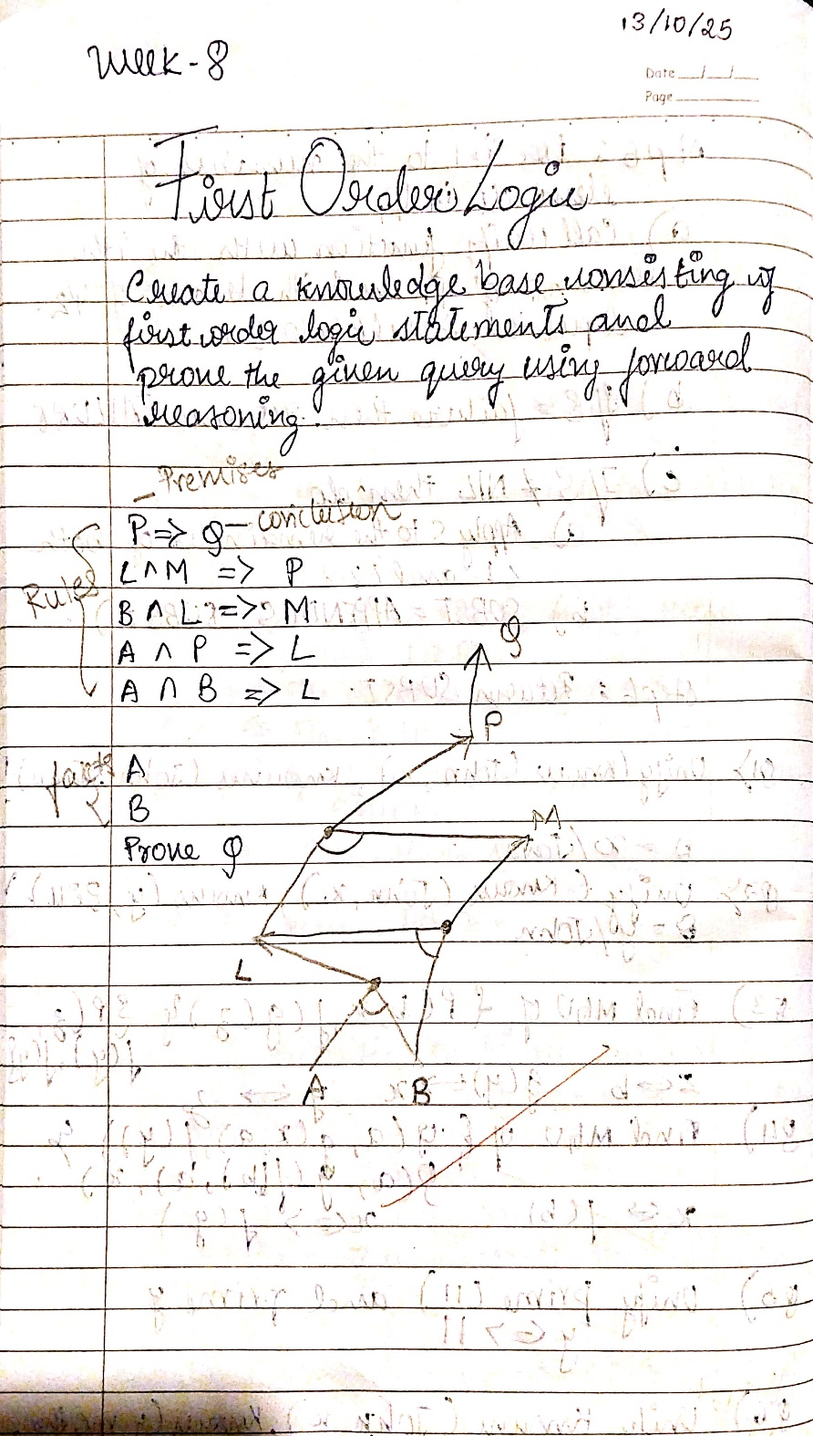
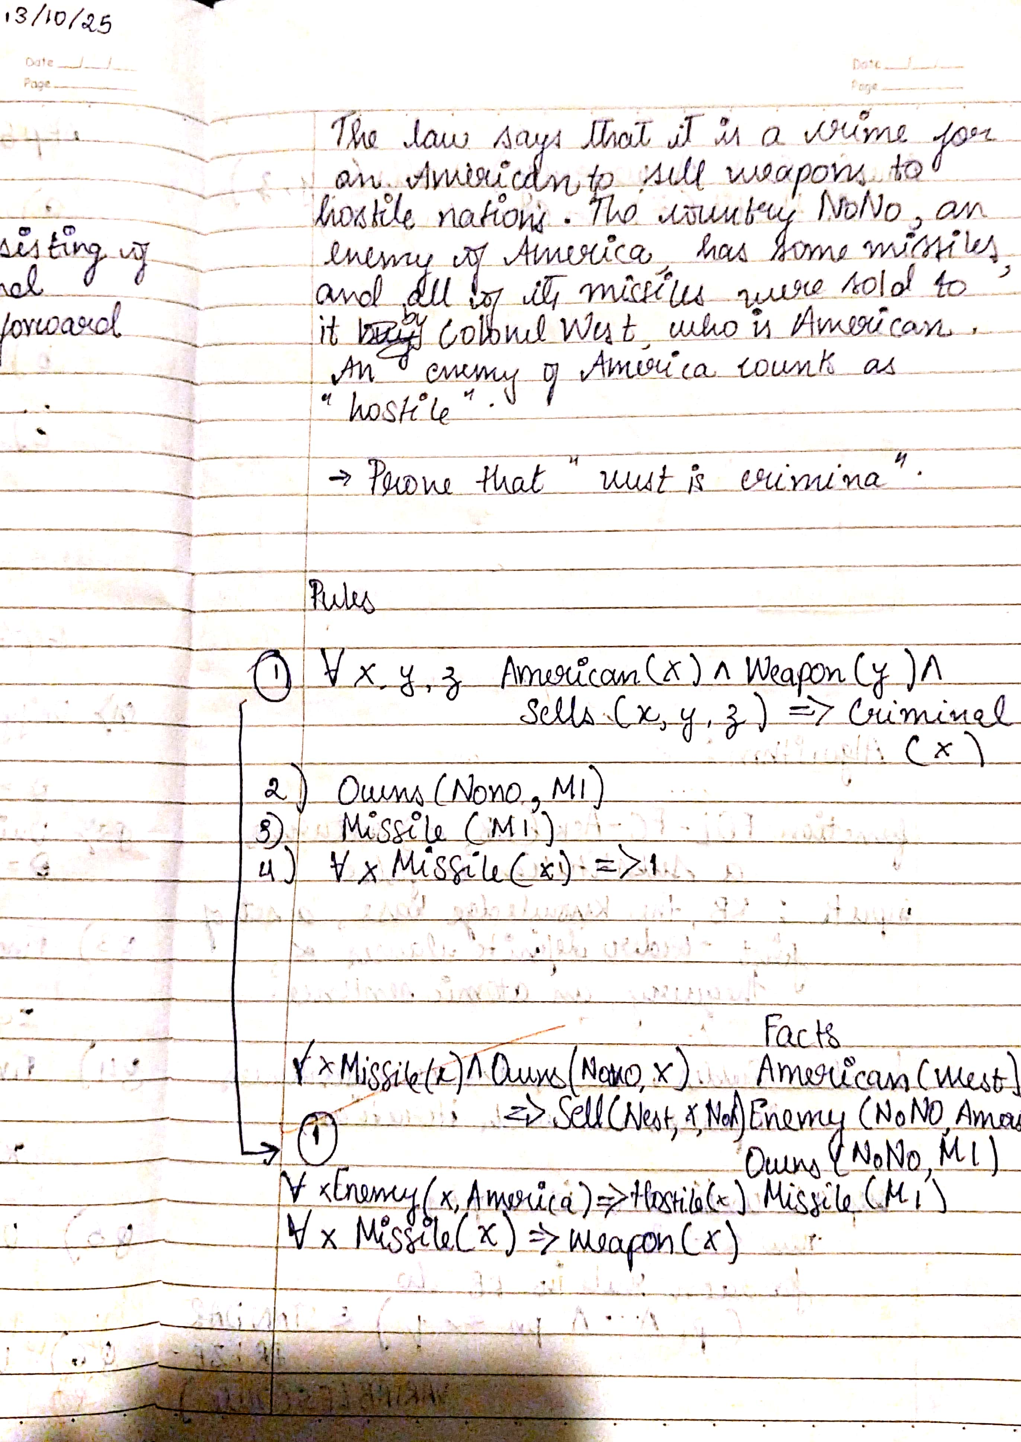
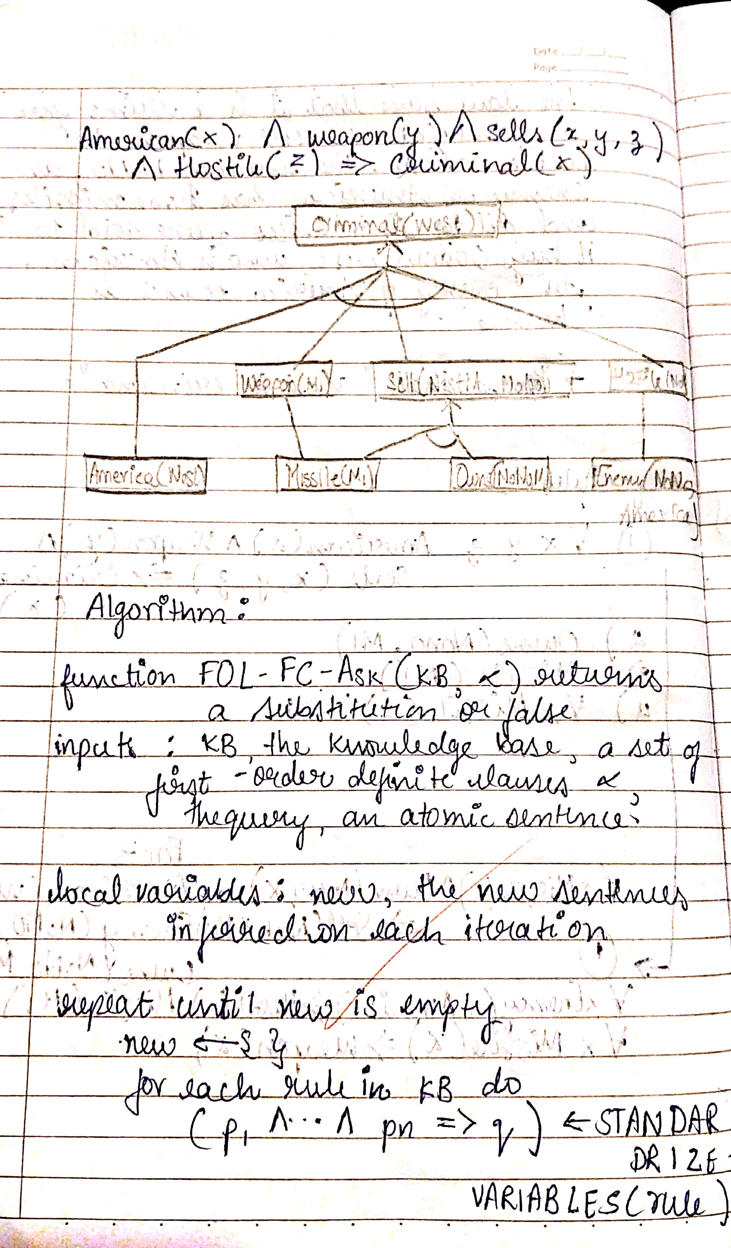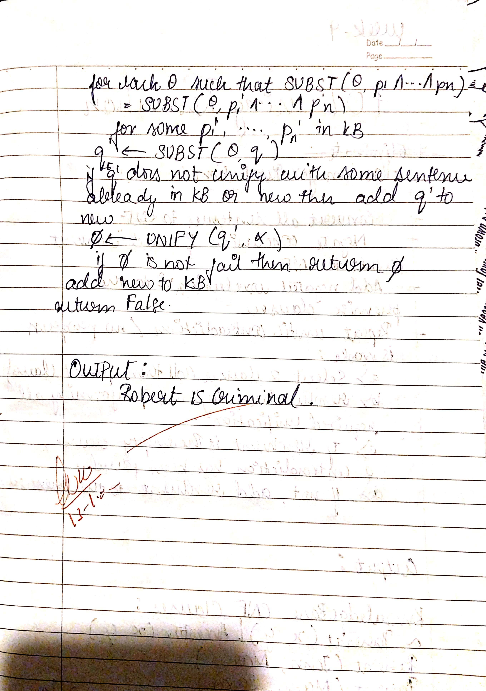
Code:
#WEEK 8
#FIRST ORDER LOGIC
# Define the knowledge base
facts = {
'American(Robert)': True, # Robert is an American
'Hostile(A)': True, # Country A is hostile to America
'Sells_Weapons(Robert, A)': True # Robert sold weapons to Country A
}

# Define the law/rule: If American(X) and Hostile(Y) and Sells_Weapons(X, Y), then Crime(X)
def forward_reasoning(facts):
# Apply the rule: If American(X) and Hostile(Y) and Sells_Weapons(X, Y), then Crime(X)
if facts.get('American(Robert)', False) and facts.get('Hostile(A)', False) and facts.get('Sells_Weapons(Robert, A)', False):
facts['Crime(Robert)'] = True # Robert is a criminal

# Perform forward reasoning to see if we can deduce that Robert is a criminal
forward_reasoning(facts)

# Output the result based on the fact derived
if facts.get('Crime(Robert)', False):
print("Robert is a criminal.")
else:
print("Robert is not a criminal.")
print("Sameksha 1BM23CS292")
output:
Robert is a criminal.
Sameksha 1BM23CS292

Program 9
Create a knowledge base consisting of first order logic statements and prove the given query using Resolution
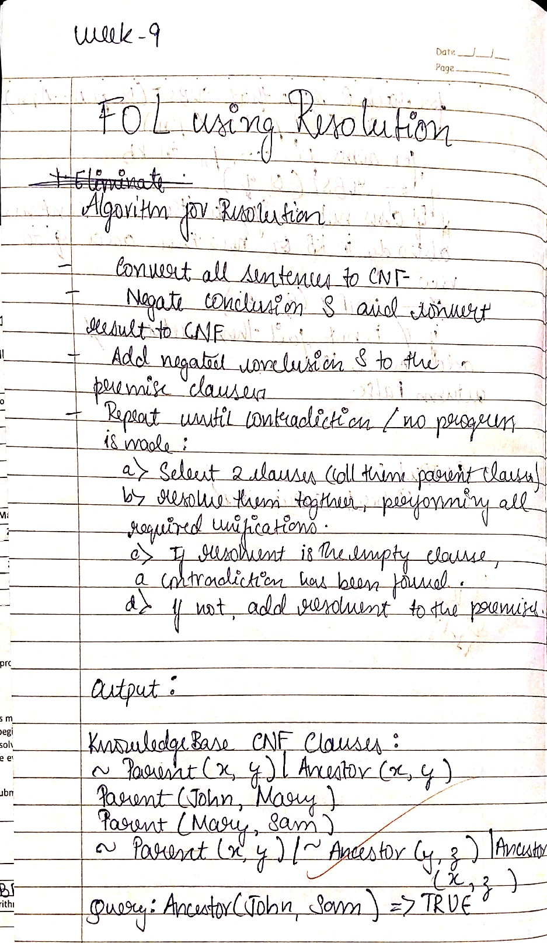

CODE:
import re
import copy

# ============================================================
# Predicate Class
# ============================================================
class Predicate:
def __init__(self, predicate_string):
self.predicate_string = predicate_string
self.name, self.arguments, self.negative = self.parse_predicate(predicate_string)

def parse_predicate(self, predicate_string):
neg = predicate_string.startswith('~')
if neg:
predicate_string = predicate_string[1:]
m = re.match(r"([A-Za-z_][A-Za-z0-9_]*)\((.*?)\)", predicate_string)
if not m:
raise ValueError(f"Invalid predicate: {predicate_string}")
name, args = m.groups()
args = [a.strip() for a in args.split(",")]
return name, args, neg

def negate(self):
self.negative = not self.negative
if self.predicate_string.startswith('~'):
self.predicate_string = self.predicate_string[1:]
else:
self.predicate_string = '~' + self.predicate_string

def unify_with_predicate(self, other):
"""Attempt to unify two predicates; return substitution dict or False."""
if self.name != other.name or len(self.arguments) != len(other.arguments):
return False
subs = {}
for a, b in zip(self.arguments, other.arguments):
if a == b:
continue
if a[0].islower():
subs[a] = b
elif b[0].islower():
subs[b] = a
else:
return False
return subs

def substitute(self, subs):
"""Apply substitution dictionary."""
self.arguments = [subs.get(a, a) for a in self.arguments]
self.predicate_string = (
('~' if self.negative else '') +
self.name + '(' + ','.join(self.arguments) + ')'
)

def __repr__(self):
return self.predicate_string

# ============================================================
# Statement Class (CNF Clause)
# ============================================================
class Statement:
def __init__(self, statement_string):
self.statement_string = statement_string
self.predicate_set = self.parse_statement(statement_string)

def parse_statement(self, statement_string):
parts = statement_string.split('|')
predicates = []
for p in parts:
predicates.append(Predicate(p.strip()))
return set(predicates)

def add_statement_to_KB(self, KB, KB_HASH):
KB.add(self)
for predicate in self.predicate_set:
key = predicate.name
if key not in KB_HASH:
KB_HASH[key] = set()
KB_HASH[key].add(self)

def get_resolving_clauses(self, KB_HASH):
resolving_clauses = set()
for predicate in self.predicate_set:
key = predicate.name
if key in KB_HASH:
resolving_clauses |= KB_HASH[key]
return resolving_clauses

def resolve(self, other):
"""Resolve two statements; return new derived statements or False if contradiction."""
new_statements = set()
for p1 in self.predicate_set:
for p2 in other.predicate_set:
if p1.name == p2.name and p1.negative != p2.negative:
subs = p1.unify_with_predicate(p2)
if subs is False:
continue
new_pred_set = set()
for pred in self.predicate_set.union(other.predicate_set):
if pred not in (p1, p2):
pred_copy = copy.deepcopy(pred)
pred_copy.substitute(subs)
new_pred_set.add(pred_copy)
if not new_pred_set:
return False # contradiction
new_stmt = Statement('|'.join(sorted([str(p) for p in new_pred_set])))
new_statements.add(new_stmt)
return new_statements

def __repr__(self):
return self.statement_string

# ============================================================
# Utility: Convert FOL Sentence to CNF Clauses
# ============================================================
def fol_to_cnf_clauses(sentence):
"""
Convert simple implications and conjunctions into CNF.
Example:
"A(x,y) => B(x,y)" becomes "~A(x,y)|B(x,y)"
"A(x,y) & B(y,z) => C(x,z)" becomes "~A(x,y)|~B(y,z)|C(x,z)"
"""
sentence = sentence.replace(' ', '')

if '=>' in sentence:
lhs, rhs = sentence.split('=>')
parts = lhs.split('&')
negated_lhs = ['~' + p for p in parts]
disjunction = '|'.join(negated_lhs + [rhs])
return [disjunction]

# Split conjunctions into separate clauses
if '&' in sentence:
return sentence.split('&')

return [sentence]

# ============================================================
# Knowledge Base & Resolution Logic
# ============================================================
KILL_LIMIT = 8000

def prepare_knowledgebase(fol_sentences):
KB = set()
KB_HASH = {}
for sentence in fol_sentences:
clauses = fol_to_cnf_clauses(sentence)
for clause in clauses:
stmt = Statement(clause)
stmt.add_statement_to_KB(KB, KB_HASH)
return KB, KB_HASH

def FOL_Resolution(KB, KB_HASH, query):
KB2 = set()
query.add_statement_to_KB(KB2, KB_HASH)
query.add_statement_to_KB(KB, KB_HASH)
while True:
new_statements = set()
if len(KB) > KILL_LIMIT:
return False
for s1 in KB:
for s2 in s1.get_resolving_clauses(KB_HASH):
if s1 == s2:
continue
resolvents = s1.resolve(s2)
if resolvents is False:
return True
new_statements |= resolvents
if new_statements.issubset(KB):
return False
new_statements -= KB
KB |= new_statements

# ============================================================
# Example Knowledge Base & Query
# ============================================================
def main():
fol_sentences = [
"Parent(John, Mary)",
"Parent(Mary, Sam)",
"Parent(x, y) => Ancestor(x, y)",
"Parent(x, y) & Ancestor(y, z) => Ancestor(x, z)"
]
queries = ["Ancestor(John, Sam)"]

KB, KB_HASH = prepare_knowledgebase(fol_sentences)

print("\nKnowledge Base CNF Clauses:")
for stmt in KB:
print(" ", stmt)

for query_str in queries:
query_predicate = Predicate(query_str)
query_predicate.negate()
query_stmt = Statement(str(query_predicate))
satisfiable = FOL_Resolution(copy.deepcopy(KB), copy.deepcopy(KB_HASH), query_stmt)
print(f"\nQuery: {query_str} =>", "TRUE" if satisfiable else "FALSE")

if __name__ == "__main__":
main()

OUTPUT:
Knowledge Base CNF Clauses:
Parent(Mary,Sam)
Parent(John,Mary)
~Parent(x,y)|Ancestor(x,y)
~Parent(x,y)|~Ancestor(y,z)|Ancestor(x,z)

Query: Ancestor(John, Sam) => TRUE

PROGRAM 10
Implement Alpha-Beta Pruning.
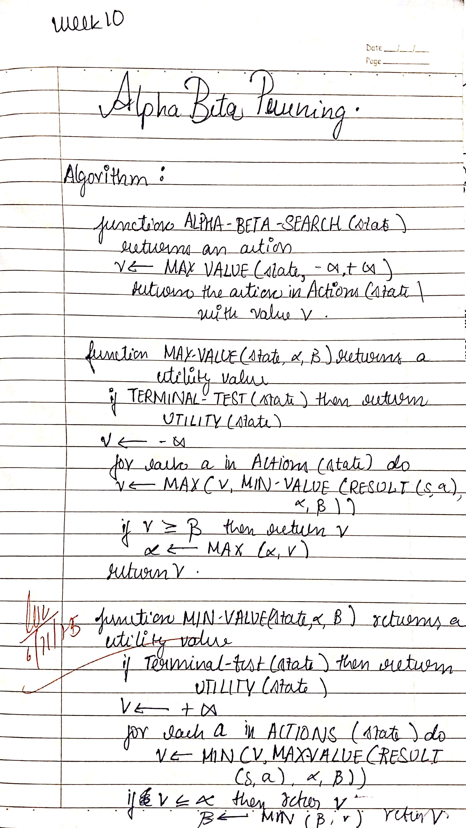
CODE:
import math

def alpha_beta(node, depth, alpha, beta, maximizingPlayer, game_tree):
"""
Alpha-Beta pruning search algorithm
node: current node in game tree
depth: current depth
alpha: best value for maximizer
beta: best value for minimizer
maximizingPlayer: True if maximizer's turn
game_tree: dictionary representing tree {node: children or value}
"""
# If leaf node or depth 0, return its value
if depth == 0 or isinstance(game_tree[node], int):
return game_tree[node]

if maximizingPlayer:
maxEval = -math.inf
for child in game_tree[node]:
eval = alpha_beta(child, depth-1, alpha, beta, False, game_tree)
maxEval = max(maxEval, eval)
alpha = max(alpha, eval)
if beta <= alpha:
break # Beta cut-off
return maxEval
else:
minEval = math.inf
for child in game_tree[node]:
eval = alpha_beta(child, depth-1, alpha, beta, True, game_tree)
minEval = min(minEval, eval)
beta = min(beta, eval)
if beta <= alpha:
break # Alpha cut-off
return minEval

# Example game tree
game_tree = {
'A': ['B', 'C'],
'B': ['D', 'E'],
'C': ['F', 'G'],
'D': 3,
'E': 5,
'F': 2,
'G': 9
}

best_value = alpha_beta('A', depth=3, alpha=-math.inf, beta=math.inf, maximizingPlayer=True, game_tree=game_tree)
print("Best value for maximizer:", best_value)

OUTPUT:
Best value for maximizer: 3

